To do liste:

1. Download DANSK, switch dev and test, and upload to HF (Matches with the switch all other places (repos, tables, etc) except for on HF and in DaCy)
2. Fix DaCy download link til DANSK
3. Ask/call Johan/Jan about the following (and write down answers):
   1. In a spaCy training session, a previous model is always chosen (e.g. when using the default configs from <https://spacy.io/usage/training> .
   2. When doing this, are we using the architecture? Or the architecture + the trained weights+biases/parameters?
   3. Where did the model we are using come from= (it’s architecture, and what was it trained/fine-tuned on?)
   4. What does it mean to fine-tune a model?
4. In intro/discussion add:
   1. Information in Introduction about silver standard and gold standard datasets and how dataset curation usually takes place (to be able to frame the methods section and the silver annotation procedure).
   2. CoNLL-2003, CoNLL-2013, Extended OntoNotes annotation schemes
   3. Differences between annotation schemes
   4. How the performance evaluation of SOTA models cannot be used to say that the new models perform better
   5. How the performance evaluation of SOTA models ONLY can be used to argue for domain specific performance
   6. Add “What are transformer models” into the introduction
   7. Add “What is fine-tuning of models” into the introduction
5. Go through the sections that are marked with **Rewrite this section* in the 2 model methods sections, and add/correct on the basis of the answers of the above questions.
6. Cmd + F “fine-tune” and see if the answers of the questions above may be used here
7. Cmd + F “transformer” and see if the answers of the questions above may be used here
8. Cmd + F “architecture” and see if the answers of the questions above may be used here
9. Skriv mail til Kenneth:
   1. Send “DANSK curation”, “Text sampling” underafsnittet til Kenneth og spørg om det er rigtigt.
   2. Spørg om han fik gjort så modellerne er implementeret i DaCy (og der derfor kan merges). Lige nu kan man nok ikke adde dem til en pipeline med en transformer pipe i sig.
      1. Hvis ikke: Henvis i thesis til branchen med min DaCy version.
10. Skriv mail til Rebekah:
    1. Du tog billede af mit spørgsmål til sidste møde. Har du svar?
    2. Ved ikke om DANSK kan udgives m. OntoNotes tingene, og med licenses fra alle de sources vi har det fra.
11. Add info til HF og GitHub for
    1. Datasæt
       1. Readme
    2. Modeller
       1. Readme’s
    3. DaCy
       1. meta_json.py scriptet
    4. Add information on datasettet til DaCy repo'et inden træning i og evt. i readme's for Modeller og dataset
12. Lav DaCy review kommentarerne færdige
13. Request et nyt review af Kenneth. Spørg her også hvordan vi gør så man kan bruge modellerne gennem DaCy
14. Få merged min PR
15. Lav visualiseringer af brug til Release sektionen og gem dem under “DANSK_eval/Thesis/Release”
16. Lav visualisering af Automated resolvement (multi-annotated processing sektionen) og gem den under “DANSK_eval/Thesis/Misc”
17. Skriv in-depth outline for introduktionen (Relevant points, citations, zotero)
    1. Brug litteraturen fra “Literature” i OneNote til introduktion og diskussionen
    2. Ikke add unødvendig teori i Introduktionen
18. Skriv in-depth outline for diskussion (relevant points, citations, zotero)
19. Skriv hele opgaven ud fra sillebensstrukturen.
    1. **Brug chatGPT til inspiration - specielt til introduktionen.**
    2. **Brug * hver gang der er noget der ikke er færdigt eller skal vendes tilbage til senere.**
    3. **Gennemlæs opgaven**
20. Sæt alting ind i Overleaf
    1. Lav først backup(s)
    2. Sæt ind
    3. Lav flere backups
21. Skriv OverLeaf Glossary
22. Efter opgaven er skrevet, sørg da for:
    1. At gennemgå min bacheloropgave, og se om der er noget tekst der kan bruges i min opgave
    2. Go through everything in the appendix and ensure it is referred to in the text
    3. At have minimum 1. sætnings metatekst til hver enkelt sektion, subsektion og subsubsektion.
    4. Ændr manuelt i de 4 plots med DANSK initial så der er flere LANGUAGE i FULL, TRAIN og DEV, (så der ikke er en så skæv fordeling -> ved at gøre dette så passer alle resten af plots’ne siden de er på test-settet som forbliver uforandret).
    5. Ensure that all information from “DANSK_eval/Thesis” is included
    6. Overvej at lave visualiseringer til “DANSK/METHODS” hvis det kan give clarity.
    7. Sørg for at ALT fra “DANSK_eval/Thesis” er med i opgaven, eller i appendix.
    8. Sørg for at appendix bliver refereret til
    9. Ensure that tables are ordered in the same fashion (large on top)
    10. Sørg for at der er en meget klar og explicit deskription af tingene JEG har lavet og det jeg IKKE har. Det kan trække meget ned i vurderingen hvis jeg ikke har det.
    11. Sørg for at plots er kodet af mig selv (eneste regel for ikke at snyde) eller at det er rightly attributed.
    12. go through everything in the DANSK_eval/output/thesis/* folders and see that it is included somewhere
    13. Strømlin sprogbrug
        1. Brug rater om personer og ikke annotated?
        2. Named-Entity Recognition? Eller uden -?
        3. Inter-rater reliability
        4. Multi-annotated texts
        5. Texts or documents
        6. “Other models”, “SOTA Models” Strømlin sprogbrug så man altid er klar over hvilke der refereres til
23. Sørg for opgaven lever op til Formalia for Kursus beskrivelsen:
    1. Thesis statement:
       1. Using background theory, methodology, empirical data appropriately to develop thesis statement
       2. Specify and narrow down a question/task/problem, and explicitly state how this thesis will answer or solve it, using academic methods.
       3. CLEAR, delimited thesis statement
       4. Argue clearly for the thesis statement
       5. Coherent work, following the delimited thesis statement
    2. General writing has to be:
       1. Clear and comprehensible paper
       2. Clear connection(!) between analytical/theoretical/empirical work AND product
       3. Assume a naïve reader in the writing
    3. In the thesis, demonstrate:
       1. Critical thinking - investigating/reflecting on issues of the field
       2. Critical thinking by investigating potential shortcomings of own methods/work
       3. Demonstrate awareness of relevant literature and relate it to thesis topic
       4. Knowledge of how current research and practices within the field relate to thesis topic and paper
       5. Relevant theories and methods and how it relates to other similar areas
       6. Identify, interpret, integrate and build upon relevant existing academic literature
       7. In-depth knowledge of thesis topic
24. I results, sørg for at performance tabellerne opfylder følgende krav:
    1. Bedste score med **BOLD**
    2. Næstbedste med *ITALIC*
    3. Order: Large øverst, mine modeller øverst, sattrup næstøverste, så daCy, og så spaCy
    4. Ligner derfor følgende:

|  | | Domain | | | |
| --- | --- | --- | --- | --- | --- |
| Dannet | SoME |  |  |
| Model | da_dacy_small_trf | **.9** | .5 |  |  |
| da_dacy_medium_trf | *.8* | **.86** |  |  |
| da_dacy_medium_trf | .7 | *.75* |  |  |

1. Få Malte, Stinne, Alek/Jørgen, Rebekah og Kenneth til at læse det igennem og få feedback
   1. Giv review pointer til dem hver især
   2. Rebekah + Kenneth:
      1. Bestemte sektioner
      2. Bestemte feedback punkter
         1. Er der noget jeg har rapporteret der kunne diskvalificere mit arbejde pga. snyd?
         2. Manglende kontekst til censor der ikke kender NLP og NER så godt?
         3. …
         4. …
   3. Stinne, Malte, Jørgen/Alek/Liv:
      1. Forståelse for udefrakommende
         1. Manglende information?
         2. Manglende kontekst?
         3. Andre ting der er iøjnefaldende.
2. Omskriv på baggrund af alles feedback
3. Grammarly/ChatGPT gennemgang (tal med Johan om at splejse)
4. Print opgaven og læs den igennem.
5. Lav evt. ændringer ud fra den printede gennemgang
6. Gennemgå formalia og læs vejledningsplanen ved aflevering af specialet
   1. Vær opmærksom på, at du ud over at uploade vejledningsplanen via studieportalen også skal vedlægge vejledningsplanen som bilag til specialet, når du afleverer i Digital Eksamen. Hvis din vejledningsplan hverken er uploadet via Studieportalen eller vedlægges ved aflevering, kan dit speciale ikke blive bedømt."
7. Få indskrevet “Sommer to-do list” ind i min alm. to-do liste.
8. Lav de ting der skal laves inden jeg går ud af studiet.
9. **Aflevér. Men notér at man ikke kan genaflevere når den først er indsendt. Den skal derfor være HELT færdig.**

Resources

* Papers:
  + connectedpapers.com
  + elicit.org
  + reserachrabbit.ai
  + zotero
  + OneNote "Literature" (I wrote notes on most important papers)
* Models and datasets:
  + OnoNote: "Overview of models and datasets" (I wrote notes on all datasets)
* Making theoretical plots:
  + draw.io
  + LucidChart

DANSK and DaCy 3.0.0:

Text domain expansion within the NER-task in Danish NLP

**Introduction 9**

Current state of Named-Entity Recognition in Danish 9

Limitations of the current state of NER in Danish 10

Alleviating limitations 11

Aim of paper 12

**Release 13**

DANSK 13

DaCy 13

**DANSK curation 14**

Text sampling 14

Annotation guidelines 15

Initial annotation 16

Quality assessment of annotations 17

Annotation improvement of multi-annotated texts 20

Annotation improvement of single-annotated texts 21

Resolving remaining inconsistencies 22

Partitioning 22

DANSK quality assessment 22

DANSK descriptive statistics 24

**DaCy model curation 29**

Methods 29

Model specifications 29

Evaluation 31

Results 32

**State-of-the-art generalizability 39**

Methods 39

Models 39

Named-Entity label transfer 39

Evaluation 40

Results 40

**Discussion 42**

DANSK dataset limitations 42

DaCy models 45

SOTA models and generalizability evaluation 45

Product usage and further research 45

**Conclusion 46**

**Appendix 46**

**Backup 46**

Named-Entity match types 46

# Introduction

## Current state of Named-Entity Recognition in Danish

1. NER (what is it?)
   1. NLP
   2. Tags/labels
   3. Machine learning and annotations
   4. Widely used
      1. NER in- and of itself not useful BUT
      2. NER is an important wheel in providing insights from data since most data is text data.
      3. Examples:
         1. Biomedicine
         2. Making historical newspaper on cultural heritage searchable (Europeana)
         3. *Use cases NER is one of the most famous NLP tasks used in the industry, probably because its use cases are pretty straightforward. It can be used in many systems, by itself or in combination with other NLP models. For instance, the extraction of entities from text can be used for : classifying / indexing documents (e.g articles for news providers) and then recommending similar content (e.g. news articles) customer support (e.g. for tagging tickets) analysing feedback from customers (product reviews) speeding up search engines extracting information (e.g from emails) building a structured database or a knowledge graph (see our example tutorial) from a corpus anonymizing documents. FROM :* [*https://danlp-alexandra.readthedocs.io/en/latest/docs/tasks/ner.html*](https://danlp-alexandra.readthedocs.io/en/latest/docs/tasks/ner.html)
         4. * More examples *
2. Datasets (in Danish for NER)
   1. Good gold-standard dataset DaNE, in Universal Dependencies format
      1. DaNE (and its previous datasets)
         1. Age
         2. Domains
         3. “Classical labeling” (Coarse-grained)
   2. Universal Dependencies
3. Models (in Danish for NER)
   1. Best models for Danish NER currently
      1. Scandeval
         1. <https://scandeval.github.io/>
      2. DaCy
         1. What is DaCy
         2. DaCy models
      3. Sattrupp/model
         1. Best (scandeval)
         2. Cross-trained on languages
      4. spaCy models
         1. Most frequently used
         2. Most famous
   2. *High performance with transformer model architecture models*
      1. *Masked Model transformer embedding layer and different heads*
         1. *E.g. Danish Gigaword Corpus (huge, but does not include annotations and therefore cannot be used for training NER heads directly)*
      2. *Less data required*
   3. *Large models better*
      1. *(Language Models are Few-Shot Learners, Brown et al., 2020 *)*

## Limitations of the current state of NER in Danish

1. Three main issues to unpack:
   1. No measures of generalizability outside DaNE
   2. No models without this potential generalizability issue
   3. No models with fine-grained tagging
2. **No measures of generalizability outside DaNE**
   1. DaNE (standard for NER in Danish)
      1. Models are trained and evaluated on DaNE
      2. Good dataset with highly performing models
      3. DaNE lacks diversity in domains and time-periods
      4. As such, the high performance does not necessarily generalize
         1. Research indicates that domain shifts have been known to cause drops in performance. Time will necessarily also play a factor.
         2. Examples
            1. Example 1 of domain shift problems
            2. Example 2 of domain shift problems
3. **No models without this potential generalizability issue**
   1. Issue closely tied to the “no measures of generalizability” issue;
   2. All models are trained on DaNE
   3. If generalizability issue, then all models suffer from low generalizability
   4. Models are being used in new domains today
      1. Examples:
         1. Example 1
         2. Example 2
   5. These uses may be problematic and for Danish NLP and NER, we need alternative models
4. **No models have fine-grained tagging**
   1. As all models are trained on DaNE, which uses classic, coarse-grained tagging
   2. Opposed to high ressource languages (i.e. English, Spanish, Chinese)
   3. Higher levels of granularity means better use, if performance doesn’t suffer.
   4. Examples of use that is NOT possible in Danish
      1. Example 1 of fine-grained NER in English (that is not possible in Danish)
      2. Example 2 of fine-grained NER in English (that is not possible in Danish)
5. *Summary of limitations:*
   1. *No measures of generalizability outside DaNE*
   2. *No models without this potential generalizability issue*
   3. *No models with fine-grained tagging*

## Alleviating limitations

1. The limitations of …
   1. No measures of generalizability outside DaNE
   2. No models without this potential generalizability issue
   3. No models with fine-grained tagging
2. May be alleviated by curating a dataset with:
   1. More domains and newer texts
   2. More fine-grained annotation
3. This allows for:
   1. Estimating generalizability outside DaNE
   2. Training new models without the potential generalizability issue
   3. Training new models with fine-grained tagging
4. This would benefit:
   1. Generally
      1. Know which models to use for which domains (because the old models are likely still very useful
      2. Fine-grained tagging
   2. Research
      1. Example 1.
      2. Example 2.
   3. Industry
      1. Example 1.
      2. Example 2.

## Aim of paper

***Very condensed with aim and how I practically structure the paper and carry it out. Keep additional info in “alleviating domains barriers”***

1. As such, this aim of this paper is thus threefold:
   1. **To introduce DANSK - Danish Annotations for NLP Specific tasKs**
      1. First version, only including NER annotations
   2. **To introduce three new models trained on DANSK in: DaCy 3.0.0**
      1. New version, including new models specifically for fine-grained NER on new domains
   3. **Evaluate current SOTA models to get estimate of generalizability**
2. This paper will therefore contain the following sections:
   1. Release
      1. Access and use of:
         1. DANSK
         2. DaCy models
   2. DANSK curation
      1. Brug dele af dette:
         1. “The procurement of the DANSK dataset would thus be an intricate process which involved a large number of customized processing steps. The outline of the previously mentioned steps is depicted in figure X* in order to provide a general overview.”
         2. “While this description of the formation of the DANSK dataset curation may provide a more conspicuous understanding, an in-depth insight of the intricacies of the process may be assessed in the following sections: “Section X, Section X1,””
      2. Methods
         1. * Short summary *
      3. Results
         1. *List type of results*
         2. Interrater reliability
         3. Descriptive statistics
   3. Model curation
      1. Methods
         1. * Short summary *
      2. Results
         1. *List type of results*
         2. Within tag and domain
   4. Generalizability assessment
      1. Methods
         1. * Short summary *
      2. Results
         1. Within tag and domain
         2. Across models (also new)

# Release

This section introduces the two new publicly available products; namely the DANSK dataset and version X.x.x. of DaCy that includes 3 new fine-grained models. The section is meant to provide a) an overview of the products, b) a crude depiction of how to access them, and c) an idea of how to make use of the products. This section will not go into the creation of the products, nor will it describe any statistical information pertaining to either distributions of the dataset or performance of the models. For information on this, please refer to section X* and section y*.

## DANSK

This paper introduces **DANSK: D**anish **A**nnotations for **N**LP **S**pecific Tas**K**s version 0.0.1. DANSK is a new gold-standard dataset for Danish with Named-Entity annotations for 18 distinct classes. The annotated texts are from 25 text sources that span 7 different domains and have been derived from the Danish Gigaword Corpus (cite*). The dataset is pre-partitioned into a training, development and testing set in order to standardize future model evaluations, allowing for comparisons across models. It may be accessed through the AI platform HuggingFaceHub at the below link, under the Creative Commons Attribution Share Alike 4.0 International license (cite*) (is this correct? or use <https://huggingface.co/datasets/DDSC/partial-danish-gigaword-no-twitter#source-data> instead?*:

DANSK access: <https://huggingface.co/datasets/chcaa/DANSK>

The dataset is meant to fill in the gap of Danish NLP that up until now has been missing a dataset with 1) fine-grained Named-Entity Recognition labels, and 2) high variance of texts in terms of domain and source origin. As such, it is the intention that DANSK should be employed in training by anyone who wishes to create models for NER that are both generalizable across domains and fine-grained in its predictions. While the dataset currently only entails annotations for Named-Entity Recognition, it is the intention that future versions of the dataset will feature Dependency Parsing, Part-of-Speech tagging and possibly revised NER annotations.

## DaCy

This paper further introduces the new version x.x.x of the DaCy Python module (cite*), distributed under the Apache-2.0 license (cite*). The new version features 3 new models for out-of-the-box Named-Entity Recognition uses; namely DaCy fine-grained large, medium and small. The idea motivation for multiple models being that larger models predict better but with the trade-off of requiring more storage. The new version also features an addition to the existing documentation of DaCy, with examples of model acquisition and model use. For using the models one may download it directly from the HuggingFaceHub using the link below. Alternatively, they may be utilized more easily by installing DaCy >= 3.x.x using a package manager. The models may then be used e.g. by running the code block seen below (chunk 1*maybe figure?*).

Model access: <https://huggingface.co/datasets/chcaa/DANSK>

*Code chunk 1 or Figure X, a screenshot of the documentation for DaCy, and displaCy showing of the texts*

The motivation for training and releasing these models stem from current limitations within Danish NLP. Current models already perform very well within certain contexts, however they potentially suffer from low generalizability of performance across domains and lack the fine-grained nature of models in high ressource languages. The 3 new DaCy fine-grained models are therefore meant to be an alternative. They may be employed for texts that stem from idiosyncratic domains or during analyses that require fine-grained annotations.

*Performance?

*Architecture?

# DANSK curation

## Text sampling

The texts in the DANSK dataset were sampled from the Danish Gigaword Corpus (DAGW); a publically available Danish text corpus which includes one billion words (Cite* The Danish Gigaword Corpus <https://arxiv.org/pdf/2005.03521.pdf>). It covers a wide array of texts authored by people across socio-economic backgrounds and Danish dialects. Furthermore, the dataset has been curated with texts from different sources and time periods.

The texts were sampled randomly from a select list of sources, up until a select number of tokens was reached. Both the list of sources along with their sampling numbers can be seen in table X*.

Subsequent to sampling, the texts were filtered so that no texts had origins from before the year 2000. Apart from the texts from Johannes V. Jensen that were completely removed, only NAAT, Danish Literature, Gutenberg, WikiSource, and Religious texts included older texts and were thus the only sources in which filtering took place.

While the source of the texts indicates the direct origin of a text, an additional abstractional layer of labeling was added to the texts; namely the domains of the texts. The term domain is for the duration of this paper used to refer to a more general origin of a text and - while more crude than source origin - should give a broader, more comprehensible understanding of the text. The mapping between domains and sources can be seen in table X* below and is derived from (cite* The Danish Gigaword Corpus <https://arxiv.org/pdf/2005.03521.pdf> ). Their paper clarifies the domain definitions as well as the reasoning behind the mapping.

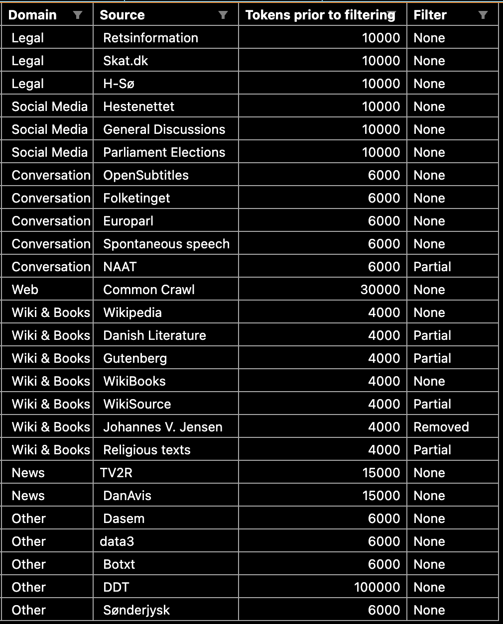

## Annotation guidelines

It was paramount to use a set of annotation guidelines for the DANSK dataset that matched the high granularity that can be seen in high resource languages. By employing the set of annotation guidelines that had already been developed in the successful OntoNotes project, it would be feasible to have DANSK become tantamount to OntoNotes. These guidelines provided 18 different Named-Entity types. Please refer to table X* for a shorthand description of each of the tags. This shorthand annotation scheme was thus utilized for the initial annotations by the employed raters. The raters annotated through the software Prodigy; a scriptable data annotation tool suitable for this type of work (Cite * explosion).

Shorthand annotation scheme:

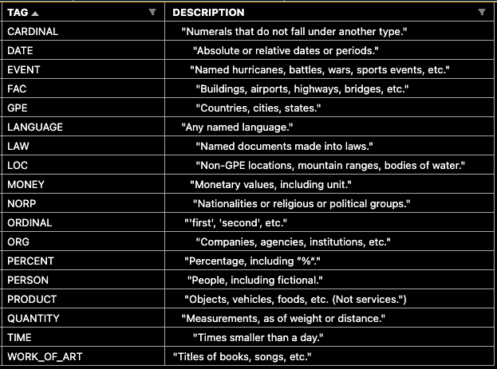

After the initial annotation by the 10 raters, the annotated texts went through multiple stages of manual resolvement of conflicts and various corrections (section X and section Y*). Prodigy was used as a tool, throughout, as for the initial annotation. The annotation guidelines used, however, changed after assessing the quality of the initial annotations (section X)*. In this assessment, it became evident that the shorthand descriptions seen in table X* were too simplistic. The descriptions allowed for many ambiguous interpretations and did not provide enough information for properly annotating the texts. All manual resolvement of conflicts and further annotation in the later stages of the DANSK curation (section X and X and X*), therefore utilized the extended OntoNotes NER tagging guidelines (cite*). The 24* pages of tagging guidelines and 5* pages of language-specific supplemental material provided much more clarity. However, they did not provide guidelines for the edge-cases met in the curation of the DANSK dataset. For this reason, the author developed an additional supplement to the guidelines for DANSK, namely Supplement D: Danish Addendum. The addendum was developed by taking off-set in the logic in the OntoNotes extended guidelines and clarified edge-cases further. They were moreover developed to encapsulate the particularities of the Danish language, since the original OntoNotes extended guidelines were not developed with Danish in mind. Please refer to appendix X* for an overview of Supplement D: Danish Addendum.

## Initial annotation

Following the sampling of texts for DANSK, the texts underwent an annotation process.

For this, 10 English Linguistics Master’s programme students from Aarhus University were employed. They worked 10 hours/week for six weeks from October 11, 2021 to November 22, 2021. Their annotation tasks included Part-of-Speech tagging, Dependency Parsing and NER tagging. For POS, the annotators merely corrected the silver-standard POS predictions that had been created by a POS model that previously had been trained by the CHCAA. The Dependency Parsing was done from scratch.

For the NER annotation the texts were first divided up equally for the 10 annotators, with a 10% overlap between the texts to allow for calculating and assessing inter-rater reliability. The overlap was varying and thus not identical between raters meaning that overlapping documents could have anywhere from 2 to all 10 annotators. Refer to table X* for an overview of the text overlap between raters.

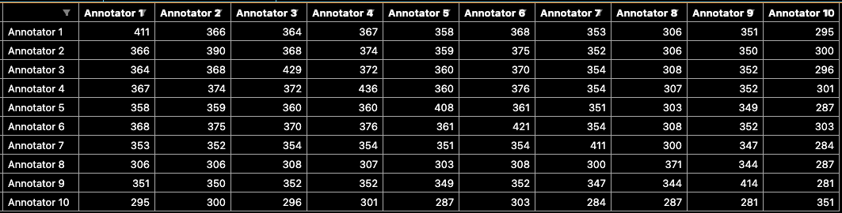

After assigning the appropriate texts to each of the annotators, the annotators were instructed in accordance with the 18 shorthand descriptions developed and utilized by OntoNotes V5 (cite*). The descriptions of the different Named-Entity types can be seen in table X* depicting the annotation scheme.

## Quality assessment of annotations

Upon having the annotators finishing the annotations, the resulting quality of the annotations were assessed.

Tag counts, per rater in the overlapping data *maybe appendix?*:

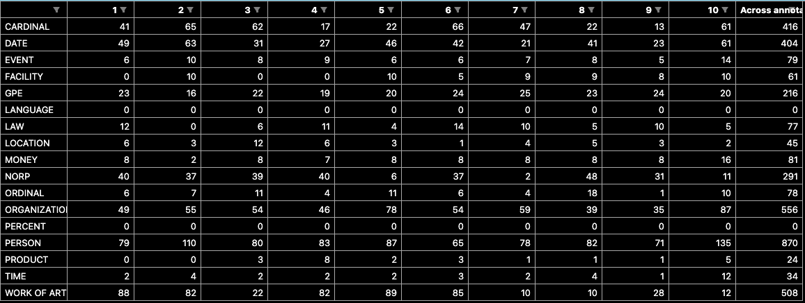

Moreover, to assess inter-rater reliability, Cohen’s Kappa scores were calculated and assessed. As these scores only may be calculated between two raters, each rater was matched with each of the other raters. The average of theses scores for each rater can be seen in table X*. Note that only words that were annotated by at least 1 rater were included in the calculation of the Cohen’s Kappa, to avoid giving an inflated view of the inter-rater reliability.

Cohen’s Kappa can be interpreted as a quantitative measure of reliability across raters, that is corrected for rater agreement by mere chance (cite*). It may be calculated using the following formula:

** INSERT COHEN’S KAPPA FORMULA **

An interpretation of some magnitude in Cohen’s Kappa may be considered arbitrary as it only truly can be contextualized through comparisons to other values for similar tasks. However, as a rule of thumb, values between .40 and .75 have generally been considered fair to good, while values lower or larger have largely been considered poor and excellent, respectively *cite (JL Fleiss et al (1981, Statistical methods for rates and proportions).

Average Cohen’s kappas per rater table (remove left column*):

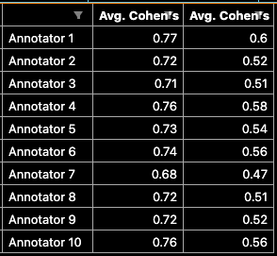

To assess the annotation consensus between annotators on a NER-tag level, additional F1-mean scores were calculated for all annotators (see section X* for a thorough description of the nature of F1-scores). The mean F1-scores for each tag can be seen in table X*.

F1-tag strict per tag*maybe appendix?*:

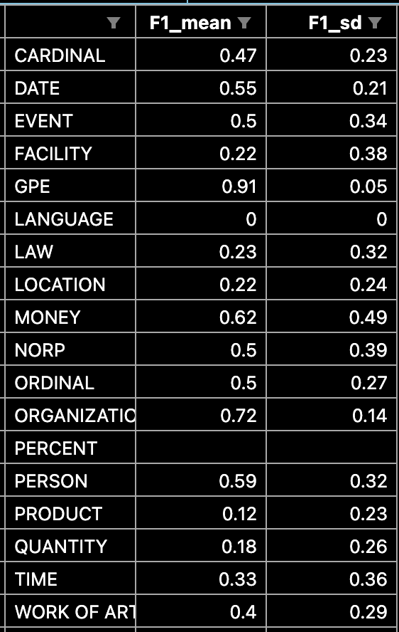

The assessment of the combination of Cohen’s Kappa scores, F1-scores as well as a manual inspection of the annotated texts yielded insights that shaped the course of action for the procurement of the DANSK dataset. Generally, the consensus between the annotators was - across the board - quite low. It was therefore deemed necessary for the annotated texts to undergo additional processing before they could be unified into a coherent, high quality dataset. Moreover, the annotation quality of rater 2, 8 and 10 was especially poor. Rater 2 and 10 seemed to have misunderstood the task to some extent and were therefore excluded. Rater 8 had incorrectly annotated pronouns as Named-Entities (such as “[man](PERSON) burde gøre” and “[sig selv](PERSON)”), despite the non-named nature of these pronouns. However, as pronouns often are excluded in the preprocessing for NLP due the limited semantic content, they are included in lists of so-called stop words. All spans that had been annotated from rater 8 were therefore excluded if the span included a word in the stopword list curated by Jens Dahl Møllerhøj that is utilized in spaCy (cite *). This stopword list can be inspected in appendix X*..

A final issue was evident in table X* in which it can be seen that some Named-Entity type annotations were severely underrepresented in the overlapping data. PRODUCT, PERCENT and LANGUAGE had only 24, 0 and 0 annotations, respectively.

To accommodate these limitations, a number of steps would be taken to enhance the quality of the annotations. The annotated texts could be divided up into two distinct groups. The two groups consisted of:

1. Multi-annotated texts, that had overlapping annotations from multiple raters
2. Single-annotated texts, that had only been annotated by a single rater

As the two groups of texts differ on the number of annotations per text, the processing and improvement of the annotations would be done separately.

## Annotation improvement of multi-annotated texts

The multi-annotated texts had an annotation version for each rater that had rated it. However, as the DANSK dataset was to include only unique texts, each text had to have its versions be merged into a single annotated text. As such, any texts with conflicting annotations had to be resolved. The curation of other successful datasets have utilized a single annotator for manual resolvement of conflicts between raters (cite* OntoNotes). However, relying on a single individual for resolving conflicts manually naturally skews the annotations towards the opinion of a single annotator, rather than the general consensus across raters. In order to resolve conflicts while diminishing this skew, an automated procedure would be employed.This automated procedure resolved conflicts in texts with predominant consensus between annotators from a set of rules.

The rules for automated resolvement of conflicts with predominant consensus were as follows:

1. Named-Entity annotations that matched across span and label in >= 50% of raters were accepted, if no other annotations in the same span lived up to the same criteria.
2. Named-Entity annotations that had zero matches on span (regardless of label) were rejected.
3. Only texts annotated by more than 4 annotators underwent the automated procedure of conflict resolvement. This circumvented the issues that any annotation in a text annotated by e.g. 2 annotators would adhere to the 50% of raters and thus be accepted.
4. In cases of two annotations existing within the same document with 50% annotation agreement between annotators, none of them would be accepted. Rather these cases would stay conflicted. E.g. “[President Trump] (PER) is the president”, “President [Trump] (PER) is the president”

**Make graphical depiction of the accept + decline + do nothing rules and what it would result in, name it: “Automated resolvement of conflicts with predominant consensus”**

After employing the automated procedure, the 886 multi-annotated texts went from having 513 (58%) texts with complete rater agreement to 789 (89%). As such, 97 (21%) of the multi-annotated texts had remaining annotation conflicts. The remaining texts with conflicting annotations across annotators were resolved manually. For the manual resolvement, 3 of these texts were of such bad quality that they were rejected and excluded.

Finally, to ensure that any Named Entities of the type “Language”, “Percent” and “Product” had not been missed by the annotators (as conjectured in section X*), an extra measure was taken. The model TNER/Roberta-Large-OntoNotes5 was used to add these types of annotations to the multi-annotated texts (cite* <https://aclanthology.org/2021.eacl-demos.7/> ). The model predictions were then manually assessed, but none of the predictions matched the annotation guidelines and were thus not added to the texts.

This step concluded the processing of the multi-annotated texts, which resulted in a total of 883 texts that were added to the DANSK dataset.

## Annotation improvement of single-annotated texts

The single-annotated texts had only a single set of annotations per text. Since the annotation quality assessment of the multi-annotated texts revealed poor quality as well as low consensus between raters (section X*, table X*, etc.), it was assumed that the single-annotated texts suffered the same limitations. Silver annotations (i.e. predictions of a model) have previously been used in the literature to validate gold-standard annotations (cite*). The logic here being that if a gold annotation matches that of a highly performing model, then the gold annotation is more likely to be correct. However, no Danish datasets nor models employ the fine-grained Named Entity annotations that are utilized here. However, a model matching the annotation schema would be trained by utilizing the multi-annotated texts that had been already been to the preliminary version of the DANSK dataset (see section X*). A such model would thus add the needed silver annotations. Texts with agreement between model and rater would have a higher chance of being correct, and would on this basis be accepted and integrated into the DANSK dataset. The remaining texts with conflicts between model and rater would be manually resolved and subsequently also integrated into the DANSK dataset.

This method of improving the single-annotated texts thus consisted of:

a) model training on preliminary DANSK dataset

b) model predictions on non-processed texts

c) manual resolvement of conflicts

The preliminary DANSK dataset only included relatively few texts; inadequate for training a well-performing model. To ensure that the model had acceptable performance, 3 models were trained and evaluated, in order to find the best model. All three models were versions of the multilingual model “xlm-roberta-large” that has been found to perform well across languages (cite* <https://arxiv.org/pdf/1911.02116.pdf> ). Their training differed on the account of the data that they were fine-tuned on, however. Model 1 was fine-tuned on 80% of the preliminary DANSK dataset. Model 2 was fine-tuned on the same 80% + the English OntoNotes v5 dataset. As the English OntoNotes v5 dataset is considerably larger than the preliminary version of the DANSK dataset, it was deemed possible that the second model would perform poorly due to the large representation of the English texts. As such, model 3 was trained on 80% of the preliminary DANSK dataset, that had been upscaled (by duplicating the annotated texts) to reach the size of the English OntoNotes v5, while also being fine-tuned on the English OntoNotes v5. The latter model had the best performance on the remaining 20% of the DANSK gold overlapping texts. This model was then used to add silver annotations for all the texts that had been annotated by rater 1. To account for the low numbers of annotations of the types “Language”, “Percent” and “Product” (see table X*), TNER/Roberta-Large-OntoNotes5 was used to add these types of annotations to the texts as well (same manner as section X* which further unravels the use). This annotation process added 38 additional annotations.

Out of the 1412 texts from rater 1, the silver annotations by the models were in agreement in 759 (54%) of the texts. The remaining 653 documents had conflicting annotations. These conflicts were manually resolved and added to the DANSK dataset, except for 43 cases where the texts were of such bad quality that they were rejected and excluded. Ultimately 1370 processed texts from rater 1 were added to the DANSK dataset.

A second iteration of the silver annotation process was carried out. An instance of xlm-roberta-large was trained on the preliminary DANSK dataset that this time not only included the multi-annotated texts, but also the processed single-annotated texts from rater 1. This more than doubled the size of the preliminary DANSK dataset compared to the first iteration. This likely contributed to better model predictions for this second iteration, and is the motivation for only predicting and resolving the texts from a single rater in the first iteration. Rater 1, in particular, was chosen since his annotation standard was highest, and would thus have the best data to include for the model training (see table X*), in this second iteration. Similarly to before, the annotated texts were then duplicated until reaching the size of the OntoNotes v5 and a model was trained on a concatenation of the two. This model was then used to add silver annotations for all the remaining multi-annotated texts, i.e. those for rater 3, 4, 5, 6, 7, 8 and 9.

Out of the 13373 single-annotated texts from rater 3, 4, 5, 6, 7, 8, 9, the silver annotations by the model were in agreement in 5502 (41%) of the texts. The remaining 7871 documents had conflicting annotations. These conflicts were manually resolved, apart from 564 texts of poor quality that were rejected and excluded. The 12809 texts that had been processed into an acceptable standard were added to the preliminary DANSK dataset.

## Resolving remaining inconsistencies

Finally, as the great number of reviews yielded insights in common mistakes for the annotations, all documents were screened using a number of regex patterns (see appendix X*). If the pattern found a match in a document, the given document was manually reviewed and annotated in accordance with the OntoNotes extended tagging guidelines (cite * ) and the newly developed additional set of rules that clarify any remaining ambiguousness for Danish (appendix X*). The regex pattern search yielded matches in 449 texts, all of which were then manually assessed and any potential inconsistencies with the annotation schemes were resolved.

## Partitioning

After resolving the remaining inconsistencies, the DANSK dataset processing was finished. Hence, DANSK was randomly split up into 3 subsets; a training set consisting of 80% of the texts, as well as a validation and a test set that each held 10% of the remaining texts.

## DANSK quality assessment

Finally, upon finalizing the dataset, the quality of DANSK was assessed.

Average Cohen’s Kappa scores were calculated, however, this time on the processed, finalized versions of the multi-annotated texts. All of the non-removed raters’ texts were included, as well as the DANSK versions. For a description of the manner in which this was carried out, please refer to section X*. As expected, the average Cohen’s Kappas scores of the processed texts saw a great increase. Scores now ranged between 0.93 and 0.89, much higher than that of the initially annotated rater texts that ranged in scores from 0.47 to 0.60 (table X, Y*).

Kappa with streamlined multi (remove left column)*:

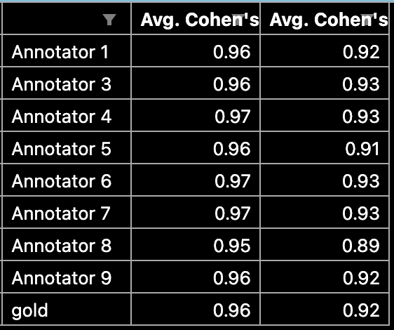

To assess which inconsistencies still remained between the DANSK dataset and the raters annotations, a confusion matrix between the annotations of DANSK and the accumulated annotations of the processed rater texts was assessed. As can be seen in figure X*, the majority of the differences in annotations are cases in which a token or a span of tokens were considered a Named-Entity by one part, while not by the other. In other words, no unequivocal systematic patterns between two Named-Entities existed.

Gold vs. rest confusion matrix *maybe appendix?*:

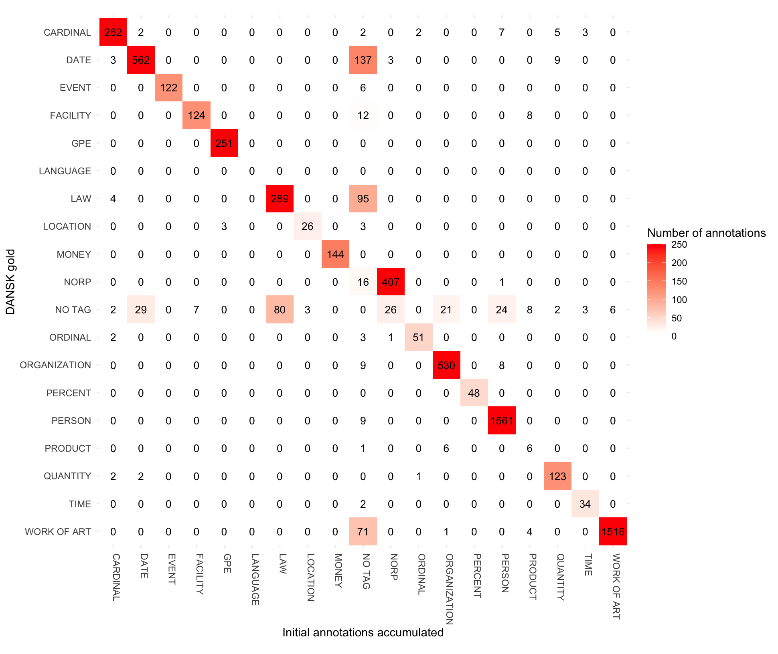

## DANSK descriptive statistics

*Maybe move below to another section?*

In order to provide complete transparency about the dataset distributions with regards to source, domain, and Named-Entities a plethora of descriptive statistics are included in this subsection (*or subsubsection?*).

The distribution of texts and Named-Entities across the full dataset as well as the individual partitions can be seen in table X*.

The distribution of texts and named-entities with respect to their domain origin across the full dataset can be seen in table X* and Y*. The same distributions for the individual partitions of the dataset can be seen in table *X1, X2, Y1, Y2, Z1, Z2* in the appendix. The distribution of texts with regards to its domain and source of origin for the full dataset as well as the individual partitions can be seen in table X* (please refer to *insert reference to DAGW paper* for a description of the domain and source labels).

DANSK descriptive partitions:

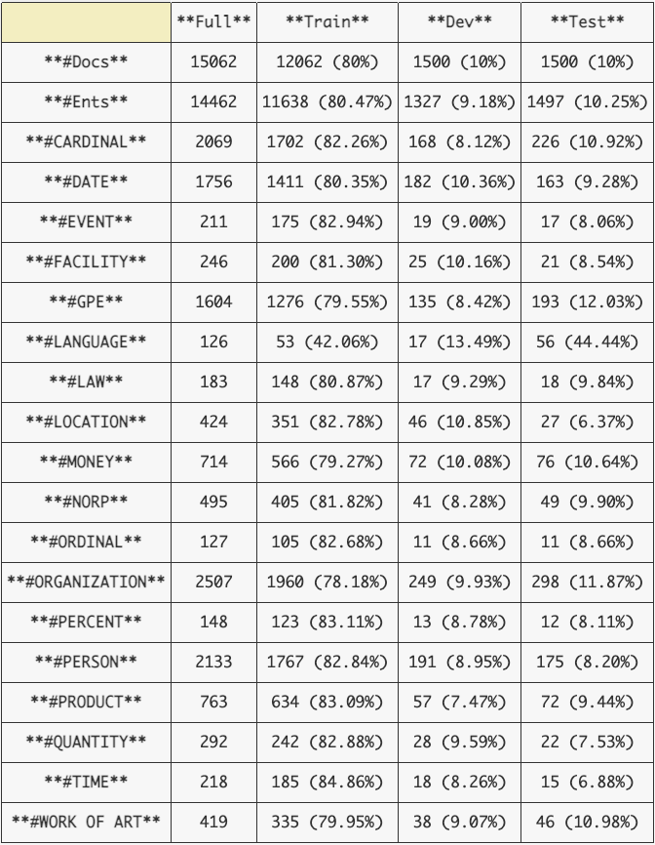

Full:

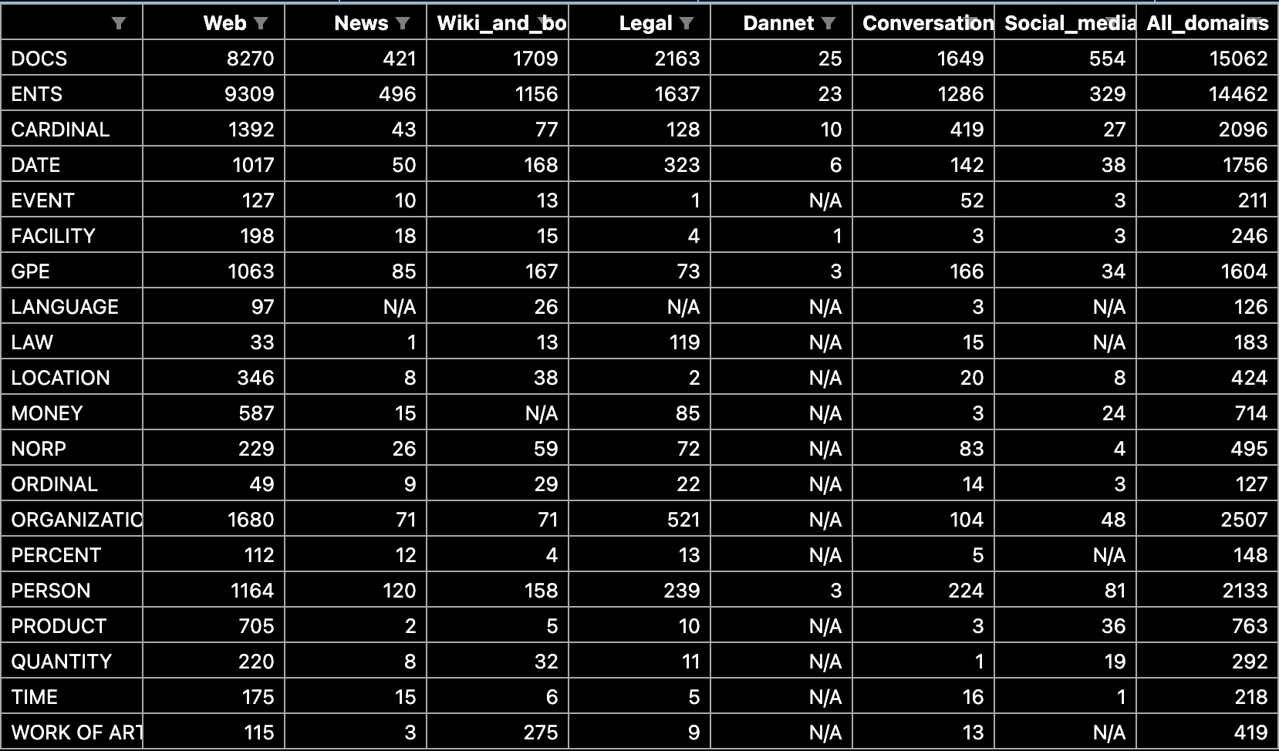

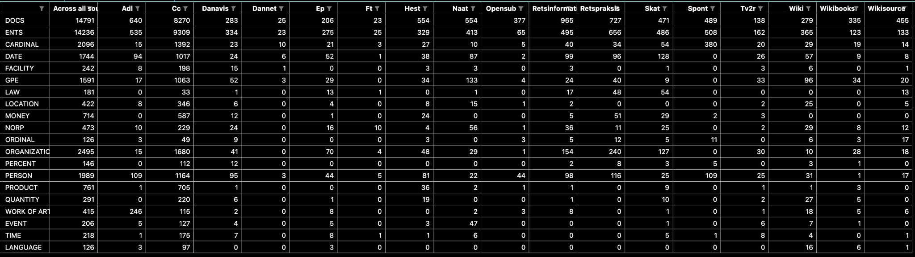

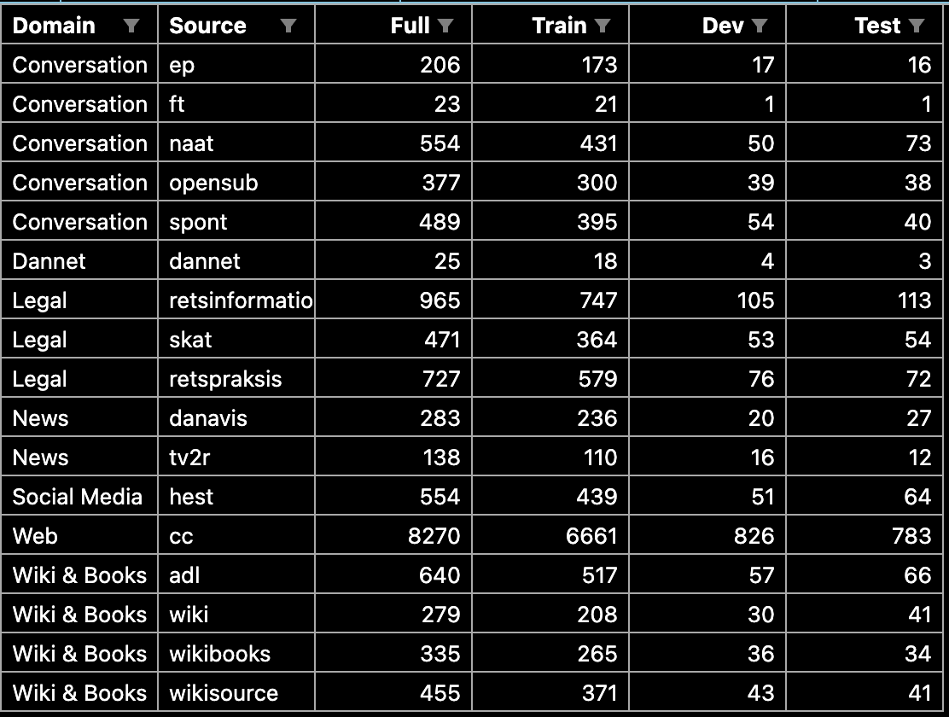

Train *maybe appendix?*:

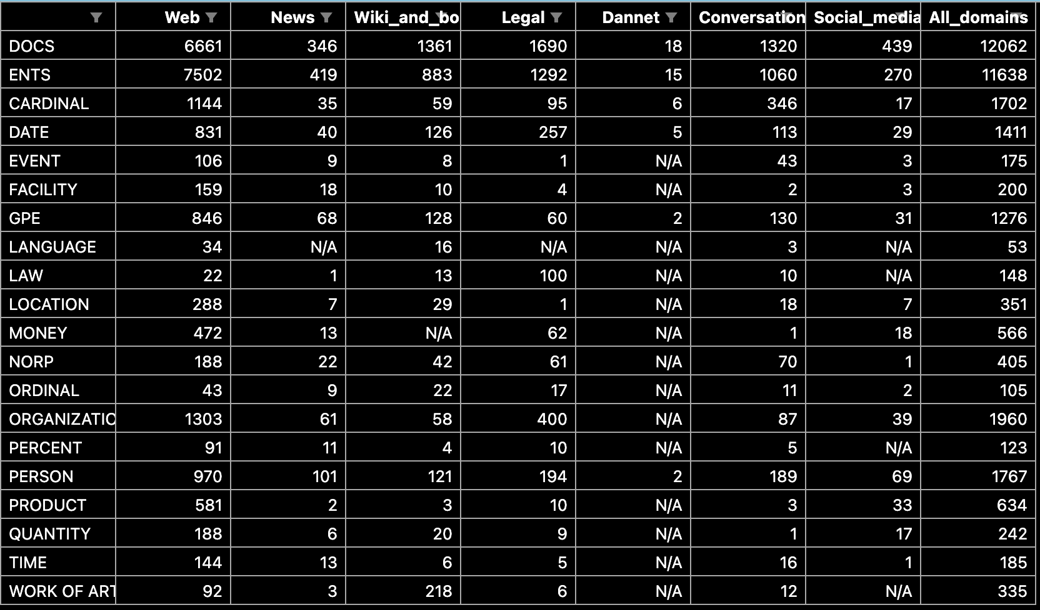

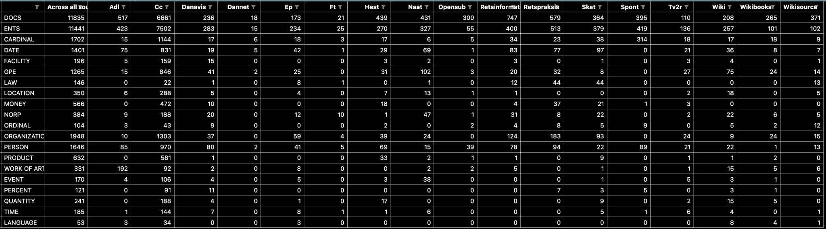

Dev *maybe appendix?*:

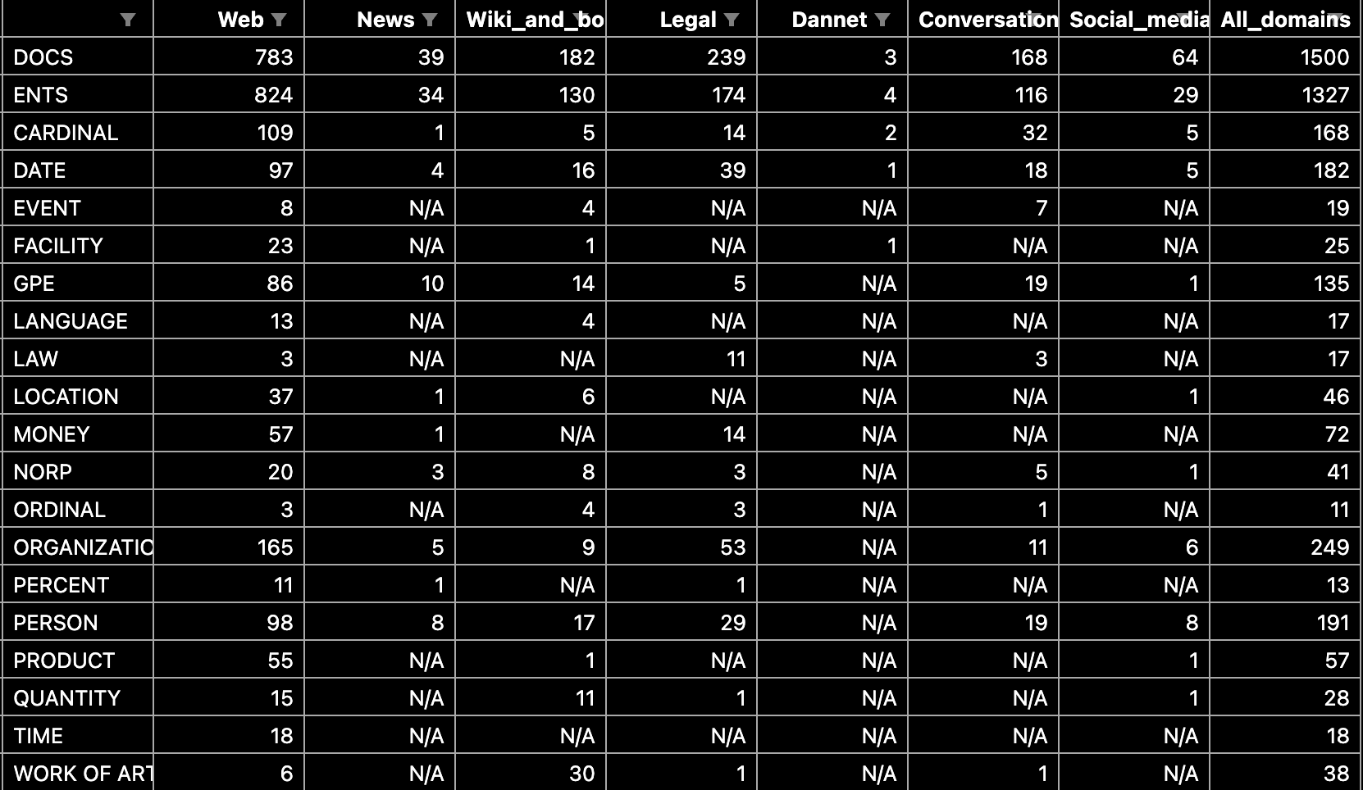

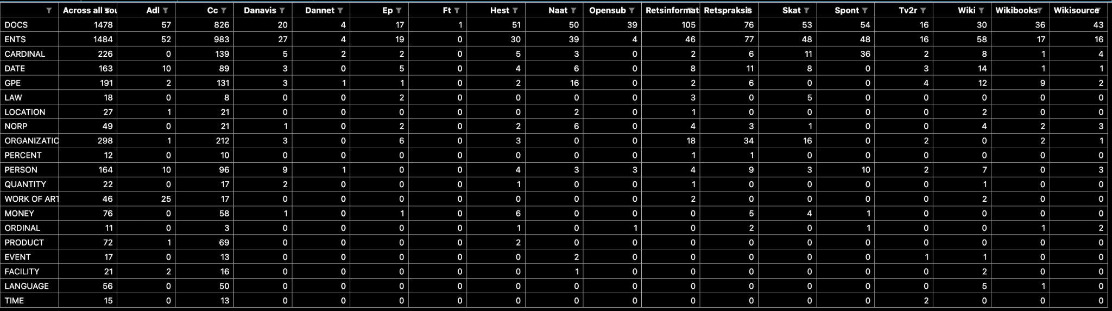

Test *maybe appendix?*:

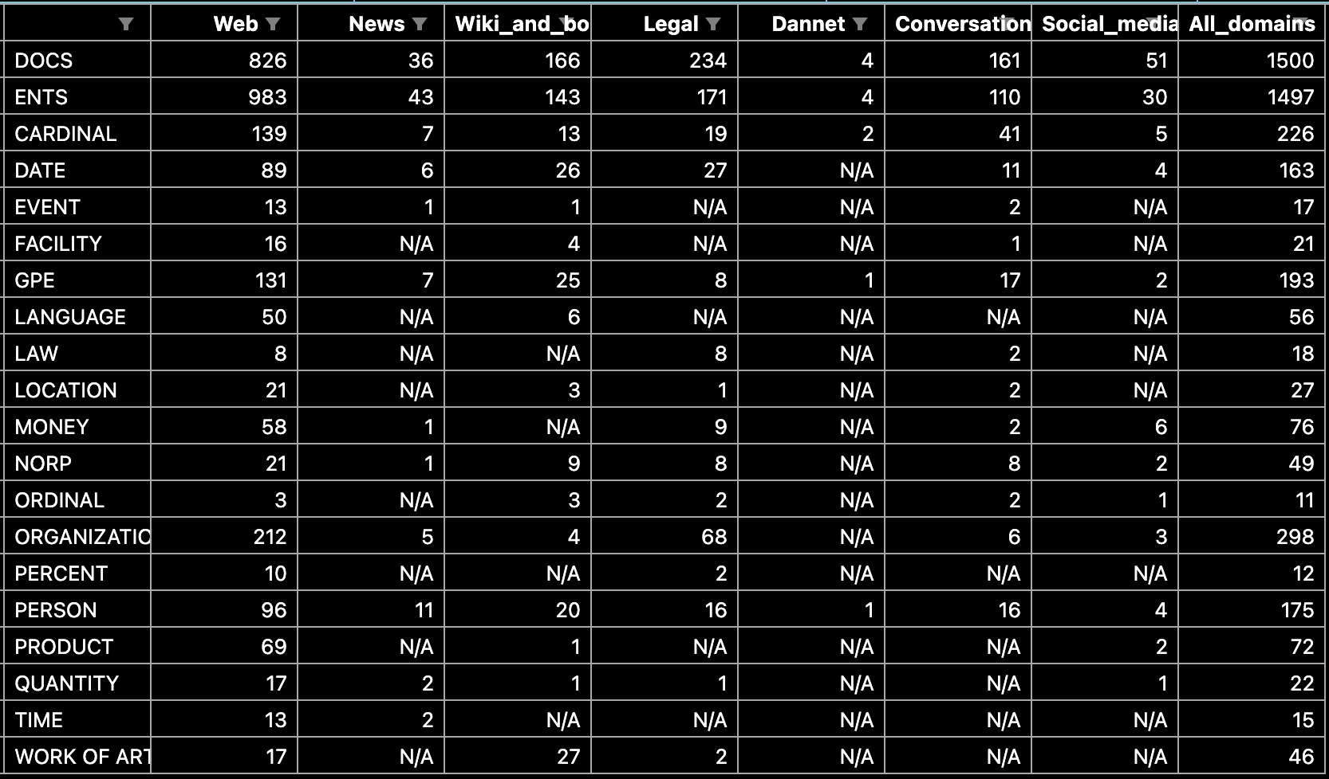

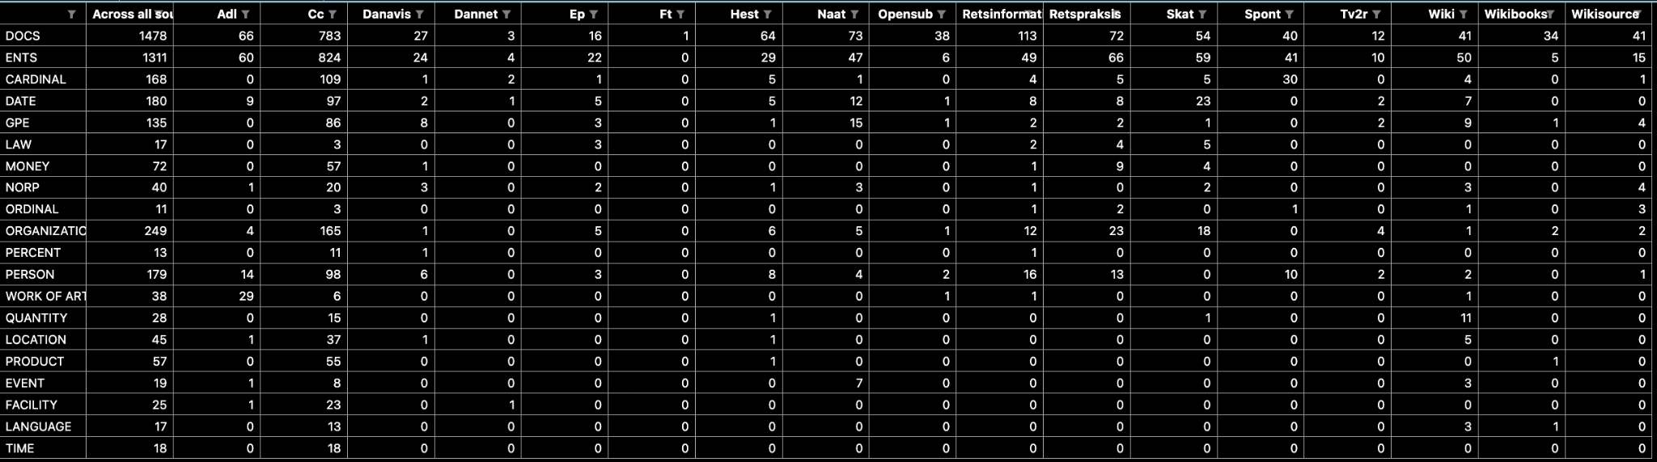

# DaCy model curation

## Methods

### Model specifications

\**Rewrite below section, after gaining understanding of what it means for a model to be a fine-tuned version of another model - ask someone from CogSci*\*

*Meta - ændr efter introduktionen og diskussionen er skrevet*

In order to contribute to Danish NLP with both fine-grained tagging as well as non-domain specific performance, three new models were trained on the newly developed DANSK dataset. The three models differed in size and included a large, medium and small model and were based on the architecture of chcaa/dfm-encoder-large-v1, NbAiLab/nb-roberta-base-scandi and jonfd/electra-small-nordic (cite* x3). These models each contain 355, 278 and 22 million trainable parameters, respectively. They were chosen as they ranked among the best performing Danish Language models within their size class. The choice of models were based on the - at the time - ScandEval benchmark scores of the 6th of March, 2023. ScandEval is an NLU benchmark tracking system developed by Dan Saattrup Nielsen and the Alexandra Institute, which affords within-language assessments of all Scandinavian Language models on Named-Entity recognition, Sentiment Classification, Linguistic acceptability and Question answering (cite* <https://scandeval.github.io/>).

The models were all fine-tuned on the training partition of the DANSK dataset using Python, Jupyter, the Python package spaCy 3.5.0 (cite x3*). They were trained on a Virtual Machine with OS Ubuntu 20.04 on UCloud, Aalborg University (cite*, cite*). The system was set up with CUDA to allow for training on the available uc-t4-1 / uc-t4 GPU in order to speed up the training process (cite*).

For hyperparameter settings, the large model utilized an accumulate gradient of 3. Apart from this, the three models shared the same hyperparameter settings for the training. They employed a batch size of 2048. Adam was applied as the optimizer with β1 = 0.9 and β2 = 0.999 hyperparameters. It used L2 normalization with weighted decay, α = 0.01 and gradient clipping with c-parameter = 1.0. The NER head of the transformer had a hidden width of 64, 2 max out pieces. Gradient descent utilized early stopping with a patience of 1600 steps and a maximum of 20000 steps. It had a dropout rate of 0.1 and an initial learning rate of 0.0005. For an exhaustive list of all configurations of the system, as well as hyperparameter settings, please refer to section Release/DaCy*).

For the progression of loss of the NER head, loss of the transformer, NER performance measured in recall, precision, f1-score as well as GPU-allocation percentage, please refer to figure X* on the training progression.

Training progression (performance on validation set):

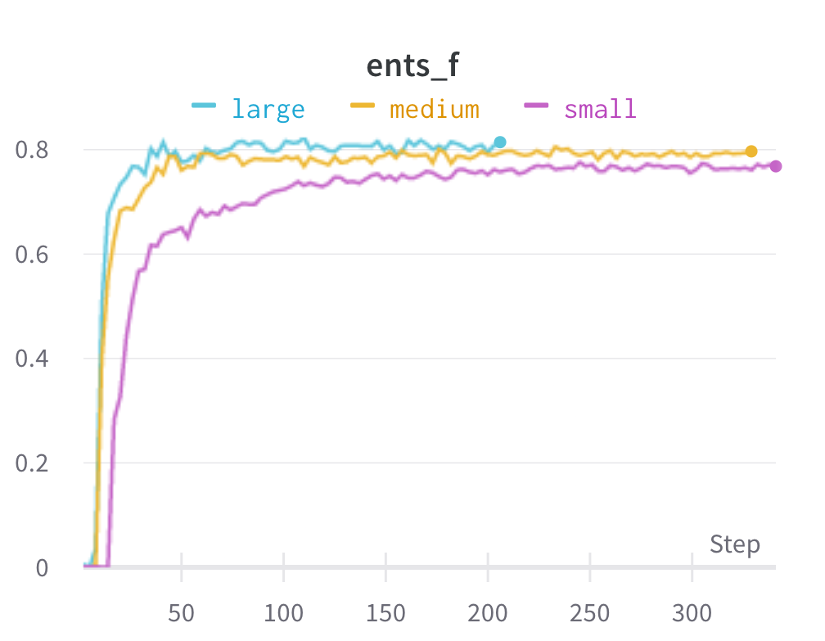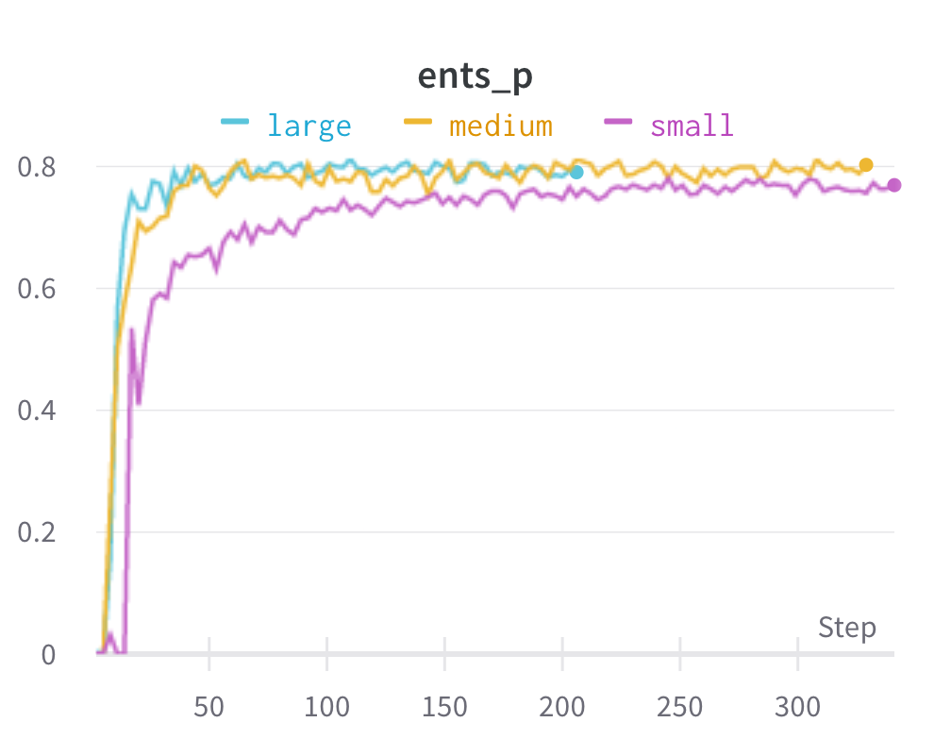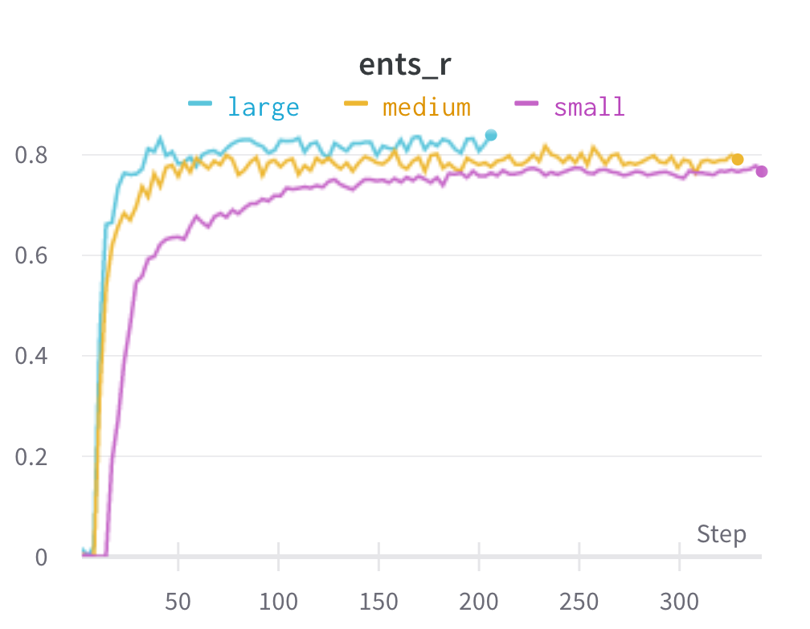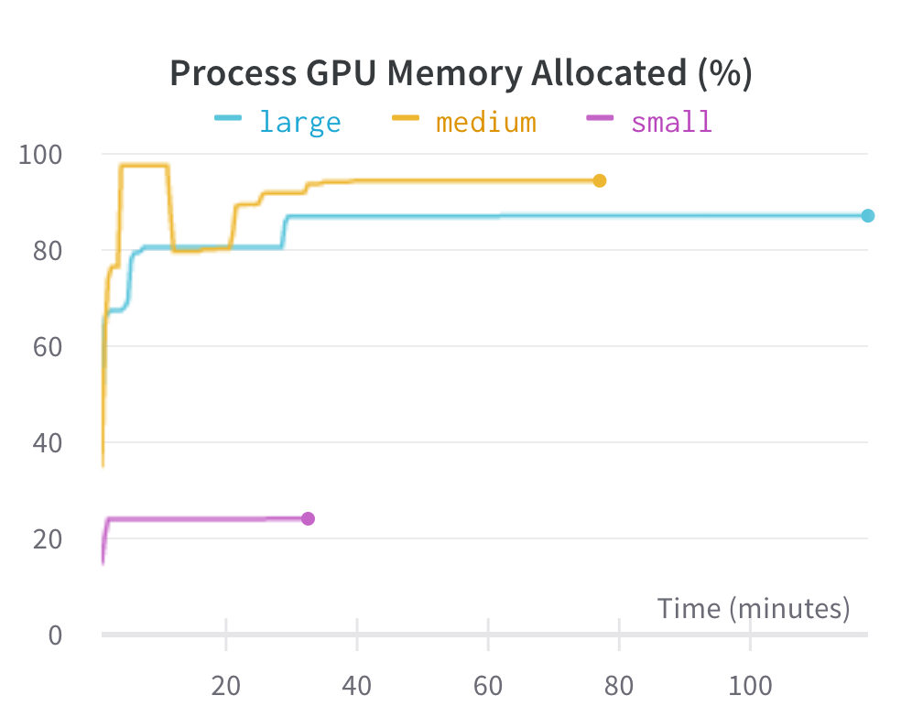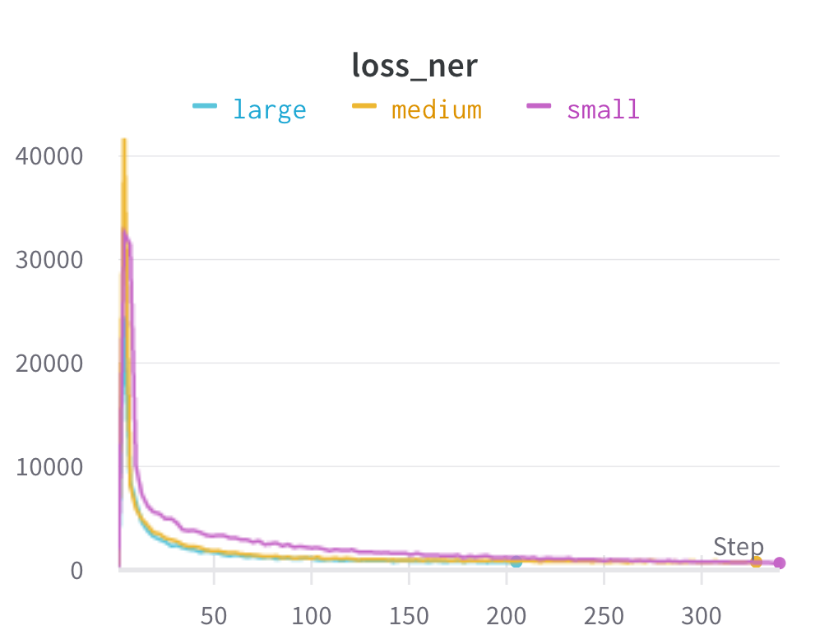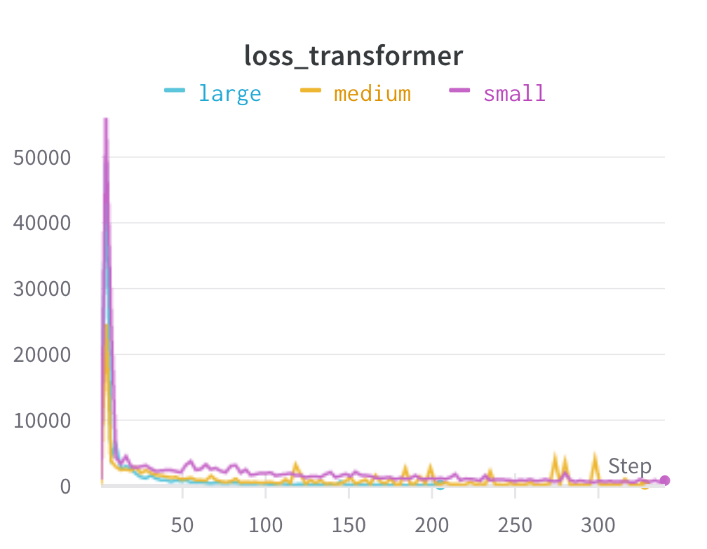

### Evaluation

After the 3 new fine-grained models had been trained, their performance was evaluated on the test partition of the DANSK dataset. To get an extensive understanding of the performance, they were evaluated on different levels of the dataset. First of all of course on a general level to get a broad overview of the performance, seeing how well the models predict on the DANSK dataset. However, since they were developed with the intention of providing the Danish NLP scene with generalizable performance across different domains, their performance was also assessed within each of the text domains. Moreover, as the new models would carry new possibilities of fine-grained annotation for Danish, the performance within each Named-Entity type was naturally also calculated.

Finally, to convey the whole picture of the models’ performances and to enable calculation of any preferred performance metric, confusion matrices are provided.

For performance metrics, precision, recall and macro average F1-statistics are included. Although it may be regarded common practice to report different types of accuracy – the percentage of correct classifications – they can often be misleading, which is why these statistics are omitted for this paper (Hossin & Sulaiman, 2015).

*Include formula for recall, precision and macro average f1-score*

## Results

This section presents the results of the performance evaluation.

A crude overview of the general performance of the three fine-grained models are reported in table X*. Domain level performance can be seen in table X*. To account for the differences in domain size, figure X* is further included as it adds an additional dimension of information through the depiction of the size of the domains. For extensive and exhaustive information on the exact distribution of domains, please refer to appendix X*. Insights into performance within tags is provided in table X. Figure X* also depicts tag-level performance, but adds information on the number of tags. Exhaustive information on the exact distribution of Named-Entities in the test set can be accessed in appendix X*. Finally, confusion matrices for the three models can be found in figure X, Y, Z*.

Overall F1-scores (and recall and precision):

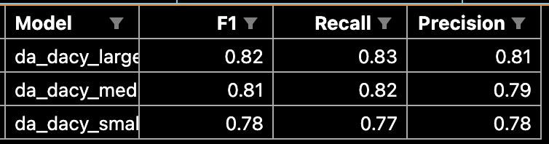

Overall F1-scores (and recall and precision) plot * probably move to appendix*:

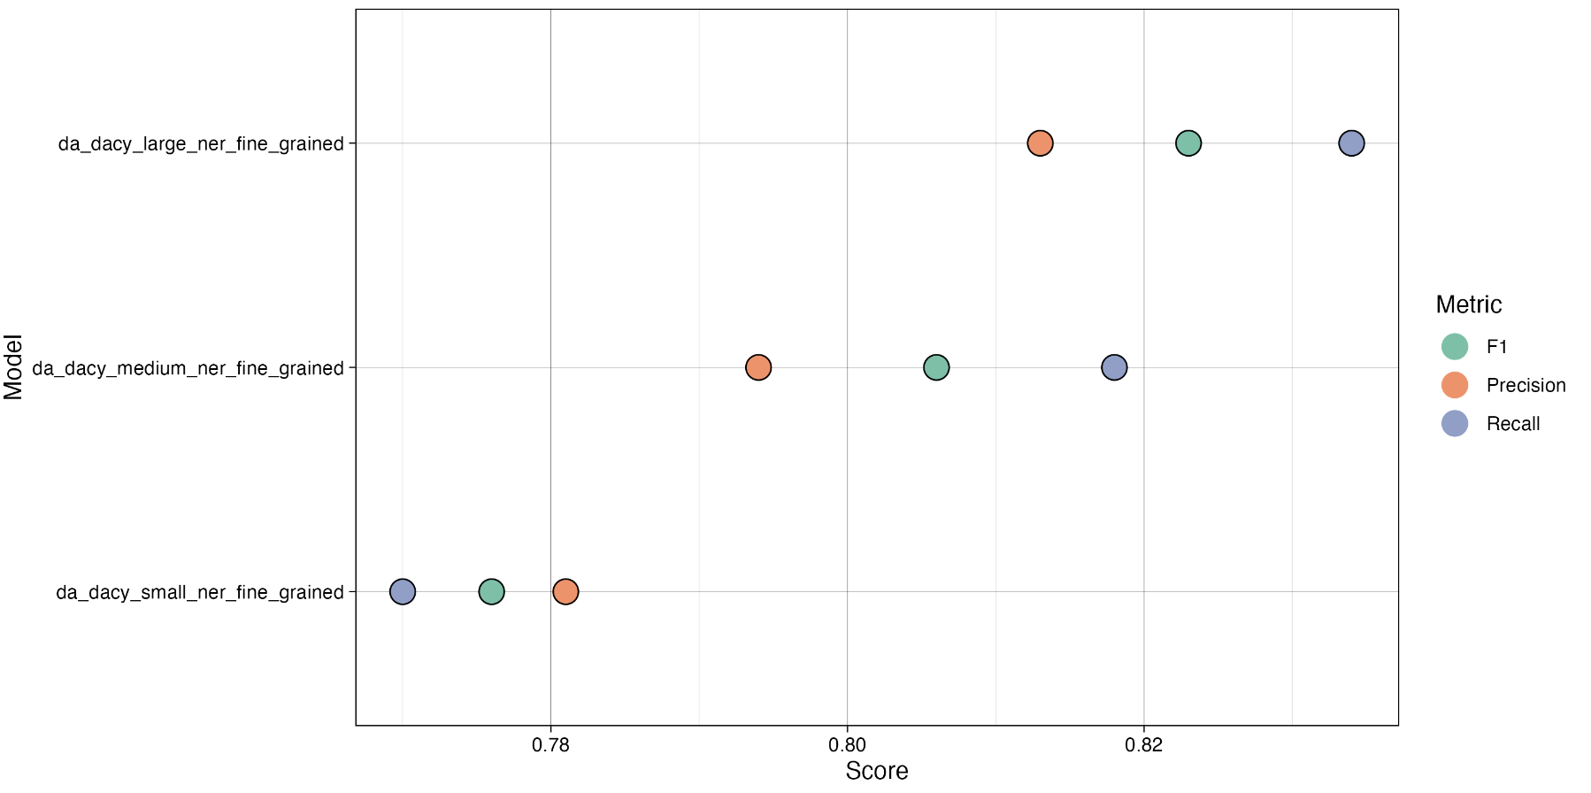

Domain F1-scores (wide format) table:

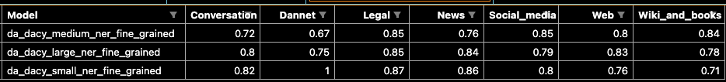

Domain F1-scores plot:

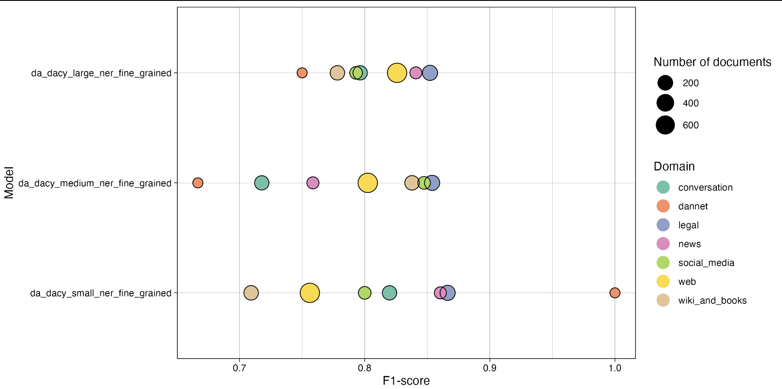

Tag F1-scores

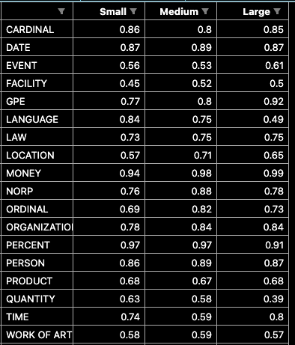

Tag f1-scores plot

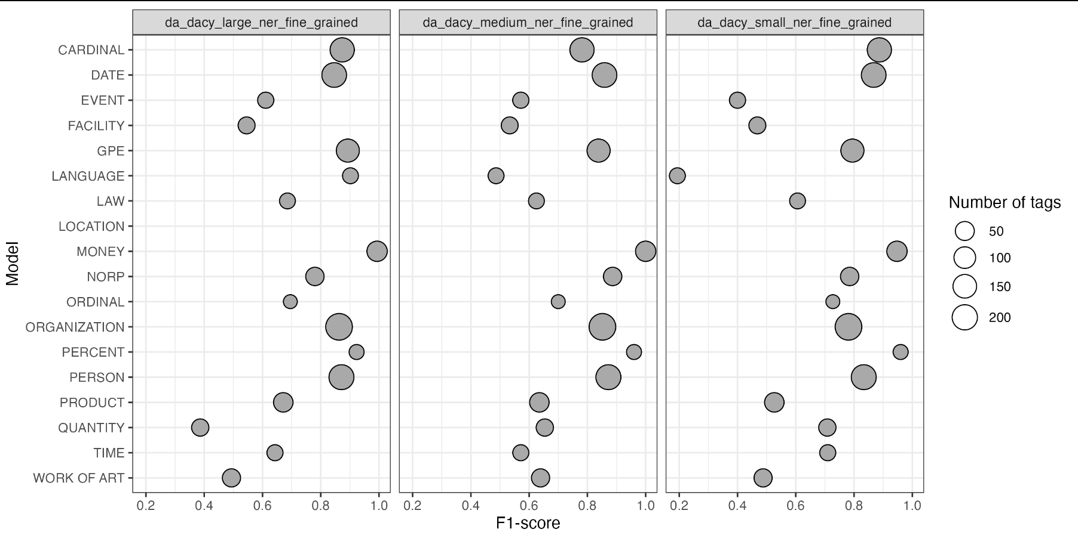

Type F1-scores*Probably move to appendix*

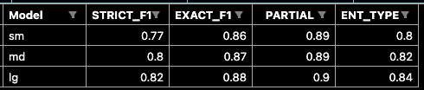

Confusion matrices:

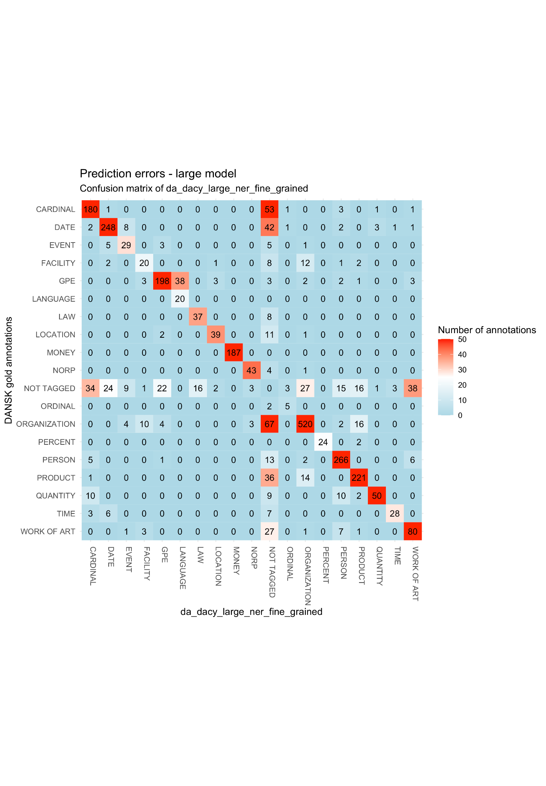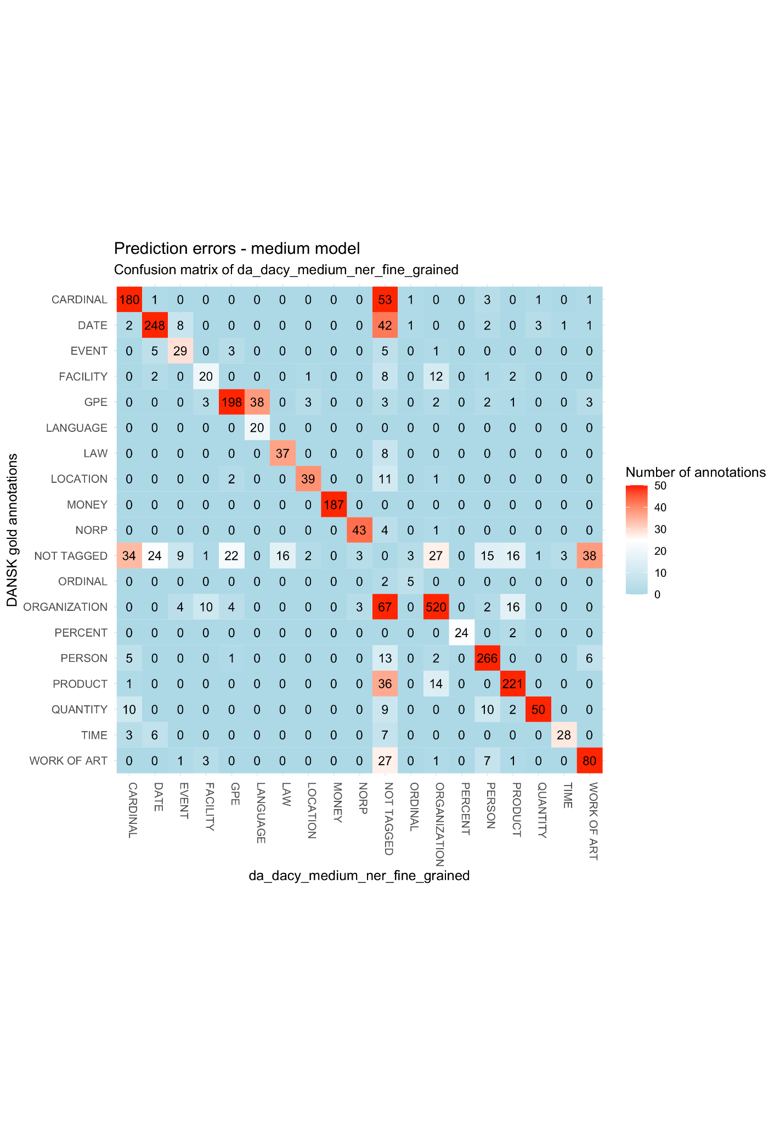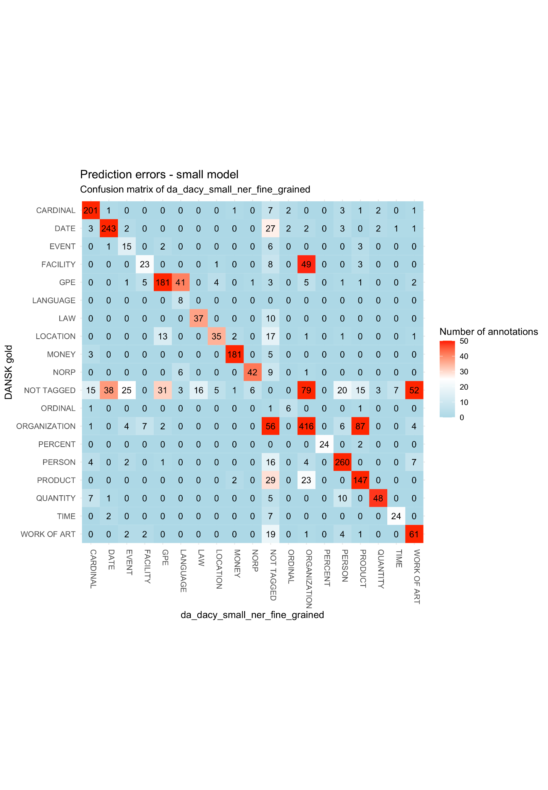

# State-of-the-art generalizability

## Methods

### Models

\**Rewrite below section, after gaining understanding of what it means for a model to be a fine-tuned version of another model - ask someone from CogSci*\*

To assess whether there exists a generalizability issue for Danish language models, a number of SOTA models were chosen for evaluation on test partition of the newly developed DANSK dataset.

At the time of the model search, the model NbAiLab/nb-roberta-base-scandi ranked highest for Danish NLP tasks, when using the ScandEval benchmarking (for more information on ScandEval, see section “Model specifications”*). Although it had already performed well on existing Danish datasets, it was conjectured that this model may be especially useful across domains. It has been pretrained on a 102 GB large Scandinavian corpus - “NbAiLab/scandinavian” - and therefore already has been known to be generalizable across the Scandinavian languages (cite*).

Apart from this model, the three v0.1.1 DaCy models (large, medium and small) were also included. They have achieved state-of-the-art performance on Danish NER, and have been shown to be the most robust Danish models, when it comes predicting texts with various augmentations (DaCy paper, cite *).

Finally, as the spaCy framework and their models are some of the most frequently - especially within the industry outside of research - their large, medium and small models for Danish were also included (cite*). Although spaCy includes a Danish transformer model, it was not incorporated in the generalizability analysis, as the DaCy medium v.0.1.1 are both versions of Maltehb/danish-bert-botxo, fine-tuned on DaNE (cite*).

### Named-Entity label transfer

A fine-grained NER dataset with 18 labels following the OntoNotes guidelines has not been publicly available until now. The aforementioned models have thus naturally only been fine-tuned to the classic, more coarse-grained DaNE dataset that follows the, CoNLL-2003 Named-Entity annotation scheme (cite DaNE paper*). This includes the 4 Named-Entity types PERSON, LOCATION, ORGANIZATION and MISCELLANEOUS. As the description of both ORG and PER in CoNLL-2003 largely matches that of the extended OntoNotes, these tags could be used in the evaluation with a 1-to-1 mapping without further handling. However, LOCATION includes cities, roads, mountains, abstract places, specific buildings and meeting points in the CoNLL-2003 scheme (DaNE, cite*). As the extended OntoNotes guidelines uses both GPE and LOCATION for describing these, the mapping in the evaluation was changed. Thus, for this evaluation of the current SOTA models, the Named-Entities for GPE were merged into LOCATION, in an attempt to make the test more accurate. As the MISC category is a diverse category meant to denote all names not in other categories (e.g. events and adjectives such as “Italian”), any of these predictions were not included. The three newly trained fine-grained models were also included for comparison to the current SOTA models. To match the merge of GPE into LOCATION of the DANSK test set, predictions GPE predictions were altered to LOCATION predictions.

### Evaluation

Similarly to the evaluation of the fine-grained models in section X*, the SOTA models were evaluated using macro average F1-statistics at a general level, a domain level and finally at a Named-Entity type level.

## Results

Overall performance:

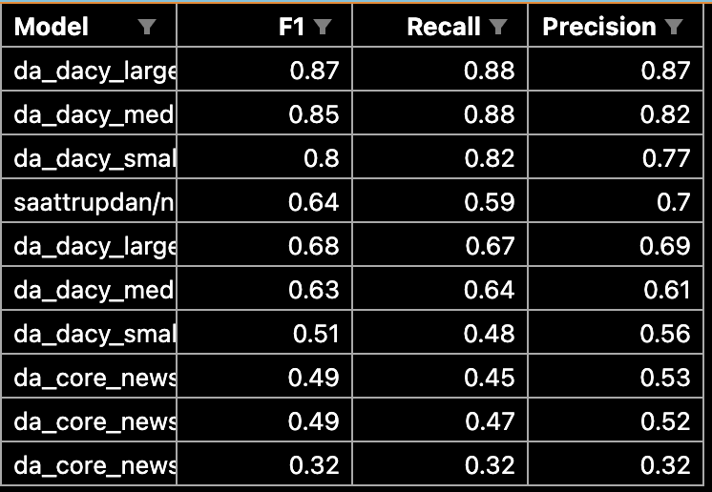

Overall performance plot:

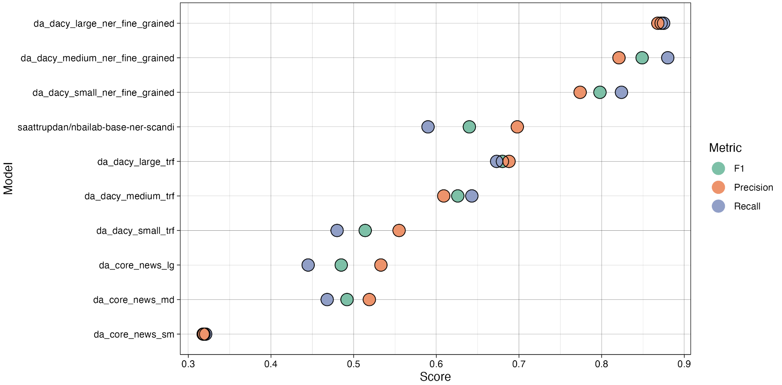

Domain F1-score

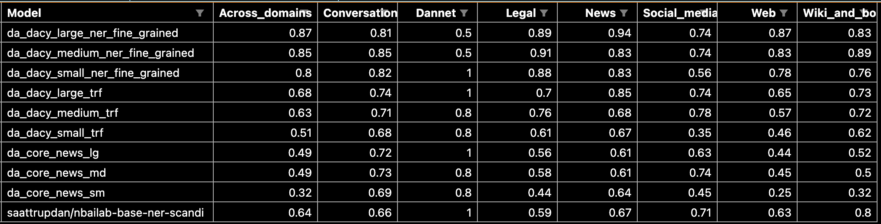

Domain F1-score plot

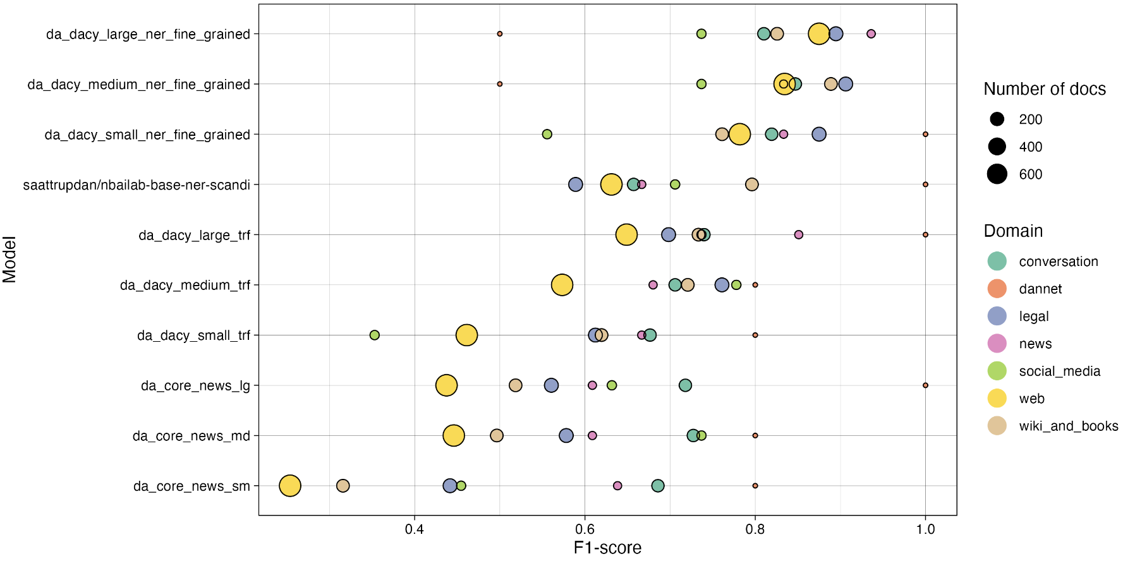

Tag F1-score

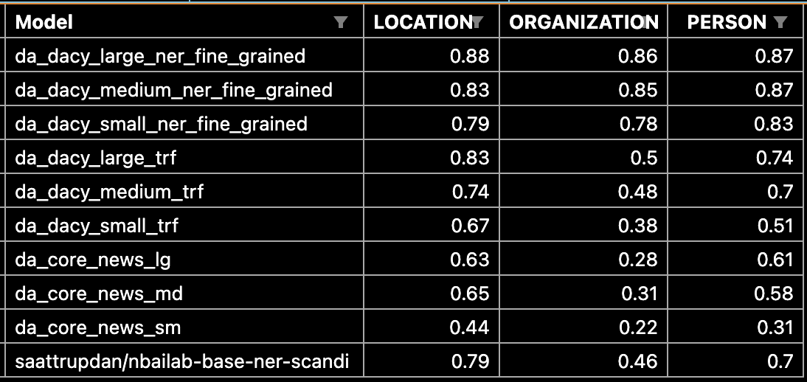

Tag F1-score plot:

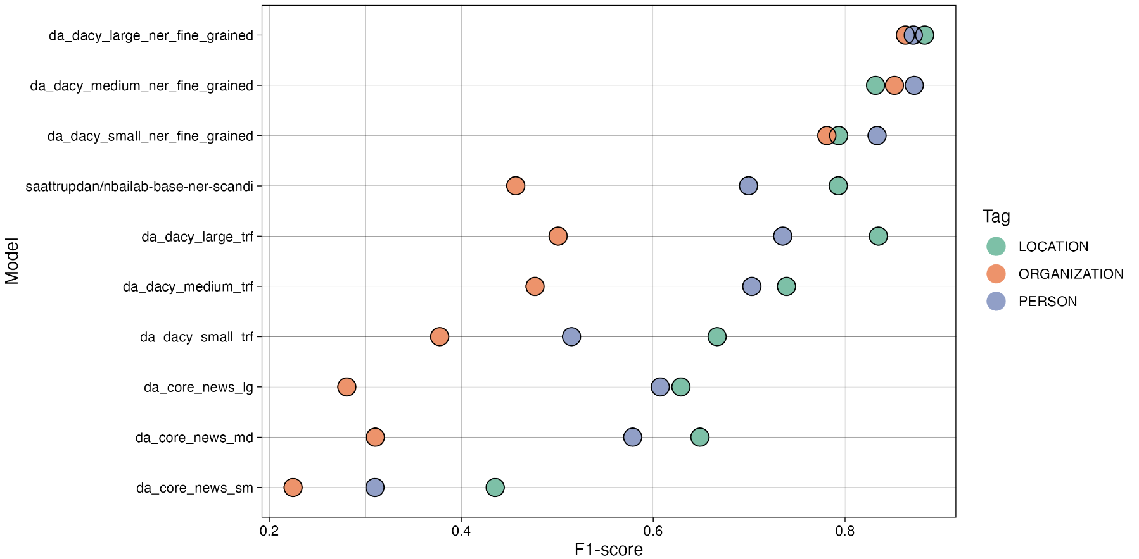

# Discussion

## DANSK dataset limitations

1. Initial annotation issues:
   1. Bad sampling
      1. Many texts randomly sampled from Gigaword Corpus were of suboptimal quality or proper texts but in which it is very hard to properly tag. Amongst it, it included even:
         1. Dutch texts "\textit{Behoud van de waddenzee og nederlandse vereniging tot bescherming van vogels.}"
         2. Texts with information on hardware products (find eksempel)
      2. Not evenly sampled across domains
   2. The annotators were not properly trained:
      1. Only given access to the shortened description of the classes (not given access to the full ontonotes guidelines)
      2. No training period
   3. As such, annotations were poor.
      1. Refer to table: “Average Cohen’s kappas per rater table:”*
      2. Show/refer to examples of bad annotations from annotators
      3. 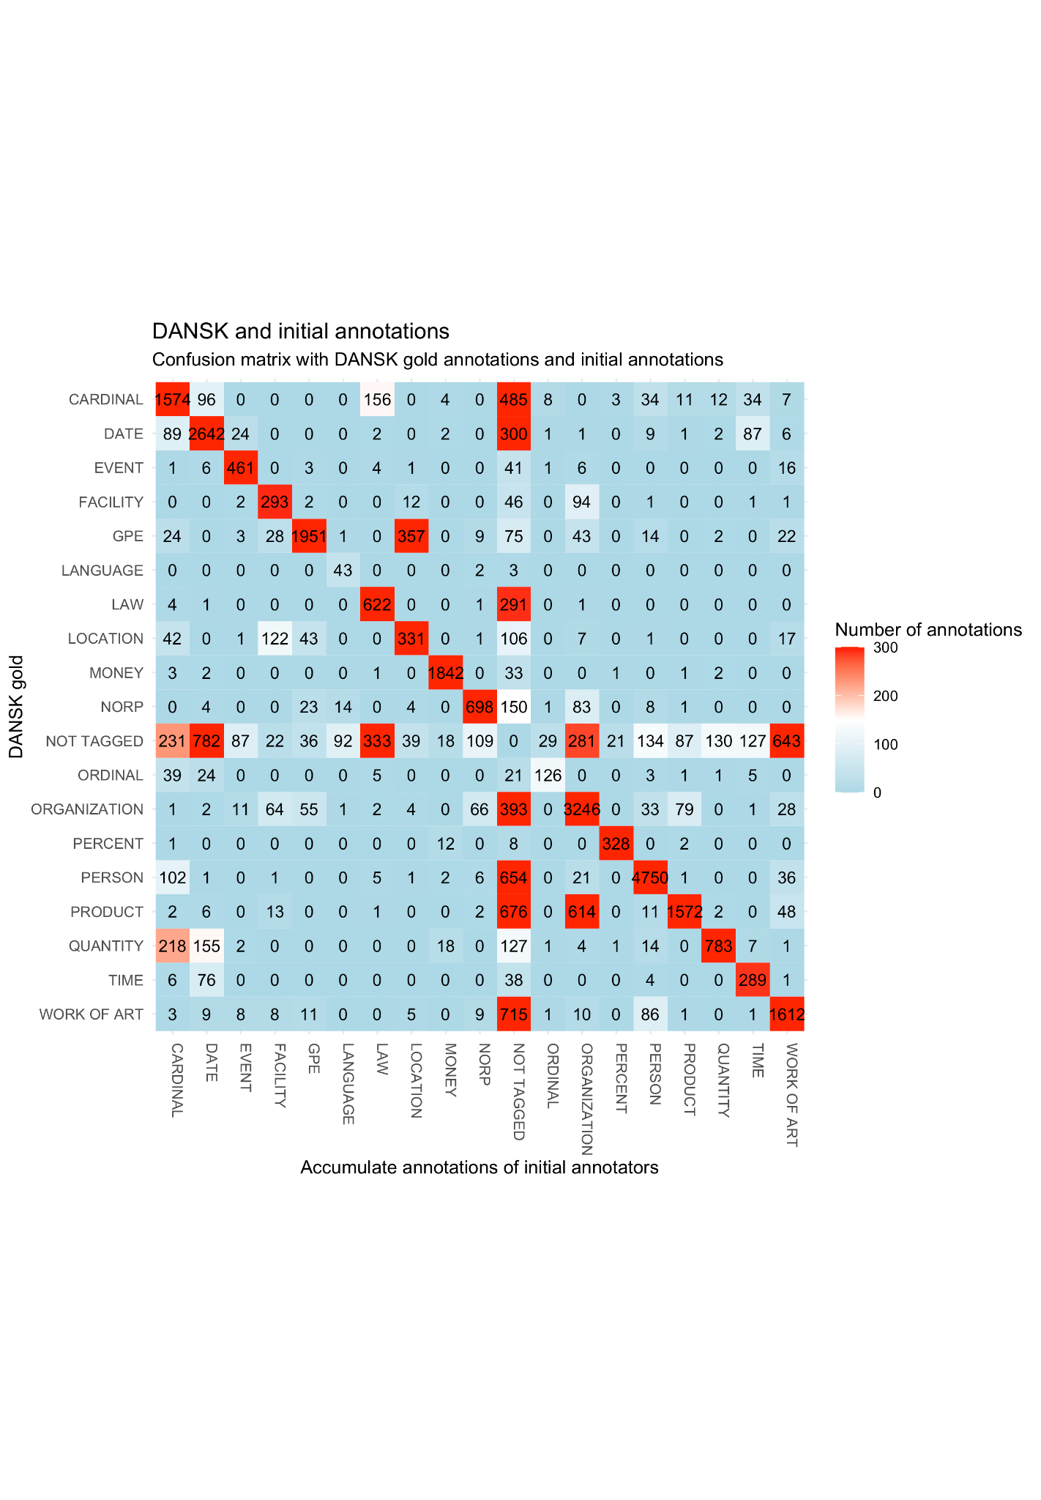
   4. Measures that should have been taken in the initial stages of the sampling and annotation process:
      1. Sampling:
         1. The sampling should have been carried out evenly across domains
         2. Low quality texts should have been discarded from the sampling
      2. Annotators:
         1. Should have been instructed to discard bad texts
         2. Should have had a trial/training period
         3. Should have been given access to the full description of the entity classes
2. Preprocessing issues
   1. Any issues with the dataset stem from poor initial quality prior to preprocessing. As a result, the preprocessing did not successfully build a dataset of the highest quality, despite its elaborateness.
   2. Regardless, it would be possible to mend and patch up the dataset in new versions using the following process to further enhance the quality of DANSK
      1. Further preprocessing should consist of:
         1. Train a model
         2. Use model to predict
         3. Manually go through errors
         4. Correcting cases in which the dataset was annotated incorrectly
      2. Repeating steps 1 through 4
      3. Adding POS, Dependency Parsing, etc.
3. Other less urgent issues included:
   1. The Ontonotes guidelines are not adequate and moreover not directly suitable to Danish
      1. "The" may never be included (but are included in some dates)
      2. Contact information may never be included (but full addresses are included)
      3. Cases where in Danish words are combined into single tokens, as opposed to English. Which makes some tokens impossible to tag in the same manner as OntoNotes (or does it?) see if there are examples in "new-resolved-cases"
      4. Mention all the cases where I made my own rules (use regex\_filter.py and new-resolved-edge-cases.txt)
   2. Would have been better to use a method such as the one described in the paper "A Joint Named-Entity Recognizer for Heterogeneous Tag-sets Using a Tag Hierarchy"
   3. Choice of partitioning;
      1. Could have used certain packages that allow for stratifying by domain and ents, rather than just doing a random split
      2. Could have partitioning so that the test had an equal number of texts from each domain. This way the uncertainty of performance on e.g. Dannet would have been better.
4. Regardless of limitations, DANSK is still very useful:
   1. Now
   2. With new versions of the dataset

## DaCy models

1. Generally
   1. Good performance, given the nature of the DANSK dataset
2. Error analysis (include heatmaps/plots, other)
   1. Within domains
   2. Within sources
   3. Within ents
3. Performance issue more likely to stem from data inconsistencies, rather than poor model training
   1. Even the case for perfect datasets (see paper: <https://nlp.stanford.edu/pubs/CICLing2011-manning-tagging.pdf>)
   2. Refer to table with interrater reliability in the end
   3. Refer to conf matrix plots for models
4. Include error analysis of model (using the heatmap from interrater reliability script

## SOTA models and generalizability evaluation

1. Poor performance generally
   1. Some models did better than others
      1. Cross-linguistic best?
   2. Explanation of why
2. Poor performance on certain domains
   1. Which
   2. Explanation of why
3. Not possible to get an accurate estimation of generalizability, as:
   1. The dataset is not perfect
   2. The old tagging system and the new do not naturally transfer
   3. The findings can therefore only be used as an indication of a generalizability problem

## Product usage and further research

1. New model performance on “old domains”?
   1. Other tagging system generates problems
   2. Perhaps this generalizability comes at a cost in performance on more conventional texts?
2. Crazy performance if also trained on English Ontonotes -> Like sattrupp/ model.
3. Error analysis would have been very interesting to look at
4. Barbara Planck version with nested is nice, and could have been nice to implement
5. E.g. the scandinavian models that are cross-trained on 3 languages, but seem to perform better on each individual language as well.
6. How will DANSK and DaCy fine-grained models help society

*Maybe include somewhere in the rest of the Discussion in the end if need more things to write about. These are relevant notes, don’t just delete!!!:*

1. *Error analysis (interrater reliability script, within each domain and across)*
2. *Still room for improvement in performance. Worth making an error analysis of the type used in https://nlp.stanford.edu/pubs/CICLing2011-manning-tagging.pdf.*
3. *Although not evaluated, the NER component will likely underperform on longer texts as the model has mostly been trained on 1 sentence at a time. They implicitly learn the entities only occur in the first sentence of a text (since they never occur later, as there are no later ents). This tendency is especially apparent in transformer models such as DaNLP, BERT and NERDA (see table in DaCy paper on performance under 5 and 10 sentences). Most likely this will not be as big an issue for the other components, as the annotated documents have been merged to chunks of 10 sentences. This was, however, not possible for DANSK, as the extensive review process meant that only parts of longer texts were annotated in isolation. Thus the out-of-sentence context was not used in the annotation.*
4. [*https://nlp.stanford.edu/pubs/CICLing2011-manning-tagging.pdf*](https://nlp.stanford.edu/pubs/CICLing2011-manning-tagging.pdf)

# Conclusion

# Appendix

1. Cohen’s kappa interrater reliability FULL table(s) X 4
   1. Only annotated/also-non annotated,
   2. Initial/End
2. Any plots or tables that do not fit in the text
3. Extra annotation rules
   1. /Users/emiltrencknerjessen/Desktop/priv/DANSK_eval/output/Thesis/Annotation_rules
4. Regex Patterns
   1. /Users/emiltrencknerjessen/Desktop/priv/DANSK_eval/output/Thesis/Regex_patterns
5. Stop words

# Backup

## Named-Entity match types

1. Differentiation between these terms are both used in the Dataset preprocessing and in the evaluation of models and thus also results.
2. Description of this is also paramount for interpreting results, as these are from strict matches.
3. <https://pypi.org/project/nervaluate/>
4. Model training
   1. 20% dev set
   2. 3 models:
      1. Overlapping_resolved + Annotator_1_resolved
      2. Overlapping_resolved + Annotator_1_resolved + OntoNotes
      3. **Upscaled_overlapping_resolved + upscaled_annotator_1_resolved + OntoNotes**
5. Model prediction on annotator 3-9
   1. Descriptive stats
      1. Total (rater 3 - 9, excluding rater 1 and overlapping): # 13373
      2. Agreement: # 5502 (excluding rater 1 and overlapping)
      3. Disagreement: # 7871 (excluding rater 1 and overlapping)
      4. Rater 1 (only included in predictions from previous model, see above, though):
         1. Agreement: # 759
         2. Disagreement: # 653
      5. Rater 3:
         1. Agreement: # 638
         2. Disagreement: # 888
      6. Rater 4:
         1. Agreement: # 1114
         2. Disagreement: # 1363
      7. Rater 5:
         1. Agreement: # 422
         2. Disagreement: # 980
      8. Rater 6:
         1. Agreement: # 1046
         2. Disagreement: # 1213
      9. Rater 7:
         1. Agreement: # 754
         2. Disagreement: # 1148
      10. Rater 8:
          1. Agreement: # 622
          2. Disagreement: # 1076
      11. Rater 9:
          1. Agreement: # 906
          2. Disagreement: # 1203
   2. Manual resolvement of conflicts
      1. Accept: # 12809
      2. Ignore: # 0
      3. Reject: # 564
6. *Manual review of docs matching certain regex patterns*
   1. *Finally, as the great number of reviews yielded insights in common mistakes for the annotations, the entire DANSK was screened using a number of regex patterns. If the pattern found a match in document, the given document was manually reviewed.*
   2. *Patterns:*
      1. *Either list here, or include in appendix \**
   3. *The search yielded 449 cases that were manually reviewed and resolved.*